CSS BRITISH HISTORY · TOPIC 1 · QUESTION ANSWERS
The Glorious Revolution and the Later Stuarts (1685–1714)
Every past question on James II, the Revolution of 1688, William III, Queen Anne and the Union of 1707 — answered in full, with answer maps

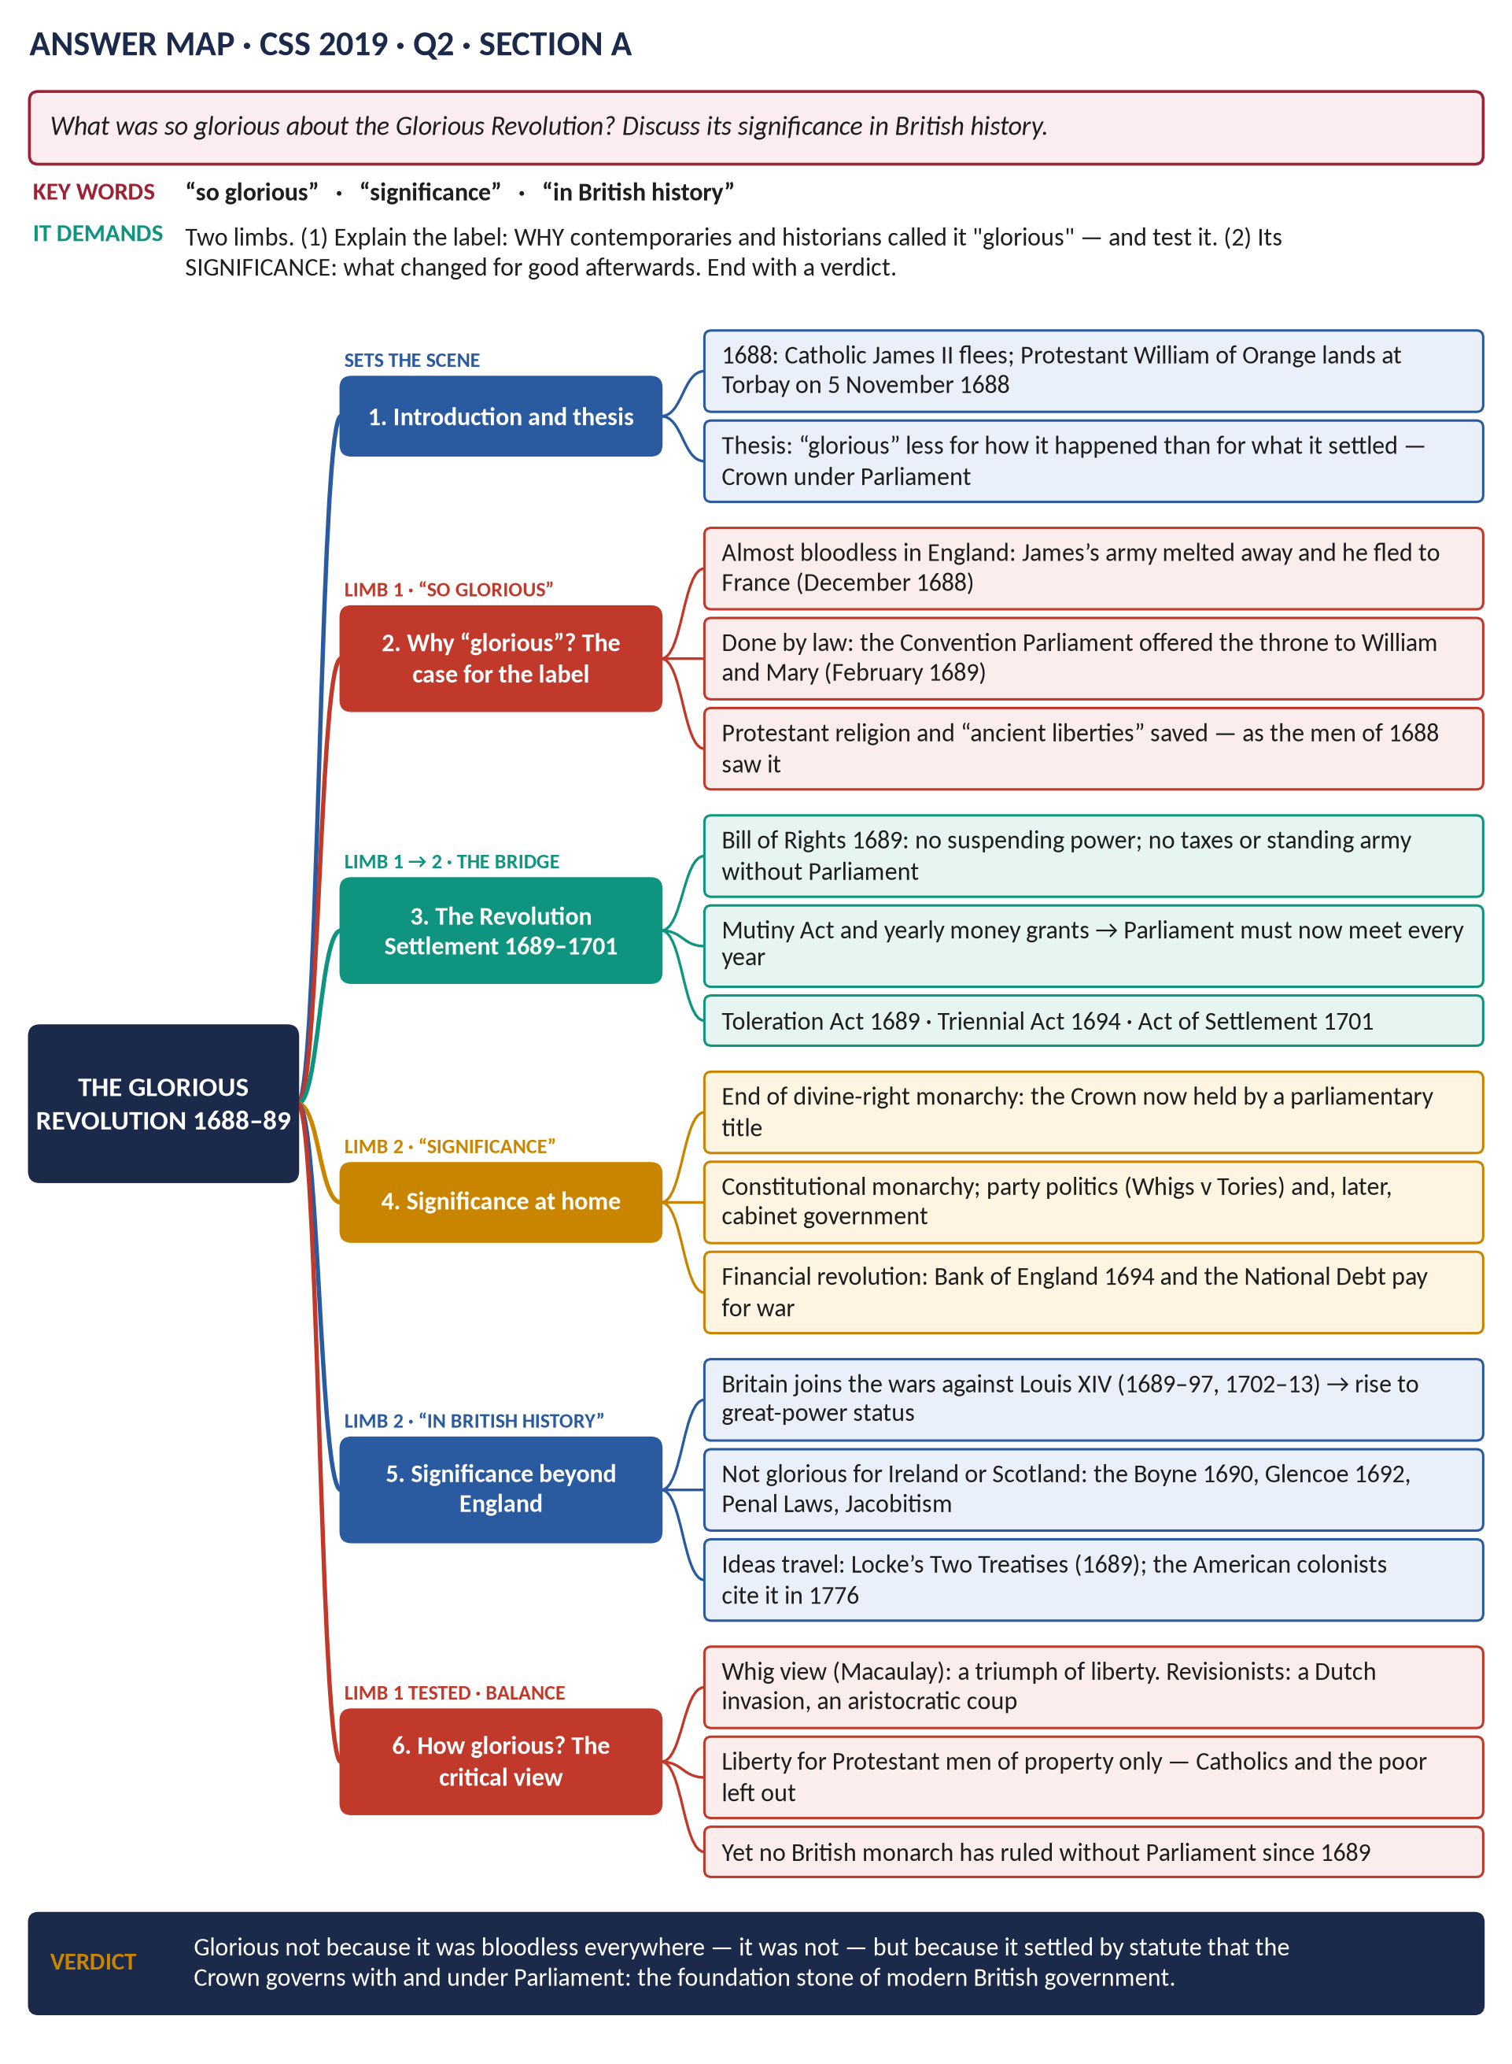
Eight full answers (2015–2025), each with its answer map, a figure and a note on why it scores; the topic's seven past MCQs solved and explained; and five predicted questions with outlines.
Topic 1 of 10 · companion to T1KB (the Knowledge Base)
Contents
HOW TO USE THIS · Updating the contents
Right-click the contents → Update Field → Update entire table, before saving as PDF.

How to Use These Answers 6
What is in this document 6
How every answer is built 6
Answer 1 · James II and the Declarations of Indulgence 7
The model answer 8
(1) Introduction: a choice that looked like necessity 8
(2) What the Declarations were 8
(3) The first pressure: James's faith and his aim 8
(4) The second pressure: Parliament refused 9
(5) The third pressure: the Tory–Anglican alliance collapsed 9
(6) The fourth pressure: the law seemed to allow it 9
(7) Why the Declaration was reissued in 1688 9
(8) Assessment: forced, or chosen? 10
(9) Conclusion 10
Answer 2 · The Causes of the Glorious Revolution 12
The model answer 13
(1) Introduction 13
(2) Long-term causes 13
(3) The main cause: James II's policies, 1685–88 13
(4) The triggers of 1688 14
(5) The European cause: William and Louis XIV 14
(6) The collapse of James 14
(7) Weighing the causes 15
(8) Conclusion 15
Answer 3 · How the Glorious Revolution Occurred — and Its Fallout 17
The model answer 18
(1) Introduction 18
Limb one — how the Revolution occurred 18
(2) Stage one: James alienates the nation (1685–88) 18
(3) Stage two: the crisis of 1688 18
(4) Stage three: invasion and collapse 18
(5) Stage four: the settlement 18
Limb two — the fallout at home 19
(6) England: a new constitution 19
(7) Scotland and Ireland: revolution by war 19
Limb two — the fallout abroad 19
(8) Europe and the wider world 19
(9) Assessment 20
(10) Conclusion 20
Answer 4 · What Was So Glorious About the Glorious Revolution? 22
The model answer 24
(1) Introduction and thesis 24
(2) Why "glorious" — the case for the label 24
(3) The Revolution Settlement, 1689–1701 — the bridge to significance 25
(4) Significance at home 25
(5) Significance beyond England 25
(6) How glorious? The critical view 26
(7) Conclusion 26
Answer 5 · Non-Jurors, High Churchmen and Latitudinarians 27
The model answer 28
(1) Introduction: one oath, three answers 28
(2) The Non-Jurors 28
(3) The High Churchmen 28
(4) The Latitudinarians 29
(5) The differences compared 29
(6) Significance 30
(7) Conclusion 30
Answer 6 · The War of the League of Augsburg and the Treaty of Ryswick 31
The model answer 32
(1) Introduction 32
(2) The long-term causes: Louis XIV's expansion 32
(3) The short-term causes and the trigger 32
(4) The course of the war 33
(5) The Treaty of Ryswick, September 1697 34
(6) The significance of the war and the treaty for Britain 34
(7) Conclusion 34
Answer 7 · Queen Anne, the War of the Spanish Succession and the Balance of Power 35
The model answer 36
(1) Introduction 36
(2) Why the war came 36
(3) How Anne's reign shaped the course of the war: phase one, 1702–1709 36
(4) How Anne's reign shaped the course of the war: phase two, 1710–1713 37
(5) The Peace of Utrecht, 1713 (and Rastatt, 1714) 37
(6) The impact on the balance of power 38
(7) Conclusion 38
Answer 8 · The Act of Union 1707: Causes and Consequences 40
The model answer 41
(1) Introduction 41
(2) Political causes 42
(3) Constitutional causes 42
(4) The terms 42
(5) Political consequences 42
(6) Constitutional consequences 43
(7) Assessment 43
(8) Conclusion 43
Part Two — The Past MCQs, Solved 44
CSS 2024 · MCQ 8 44
CSS 2024 · MCQ 18 44
CSS 2025 · MCQ 1 44
CSS 2025 · MCQ 2 45
CSS 2025 · MCQ 5 45
CSS 2026 · MCQ 1 45
CSS 2026 · MCQ 2 45
Part Three — Five Predicted Questions, with Outlines 46
Predicted 1 · "Assess the significance of the Revolution Settlement (1689–1701). Did it create a constitutional monarchy?" 46
Predicted 2 · "Examine the constitutional significance of the Act of Settlement, 1701." 46
Predicted 3 · "Evaluate the reign of William III (1689–1702): his domestic and foreign policies." 46
Predicted 4 · "Why did James II lose his throne within four years? Was his fall the result of his own mistakes?" 47
Predicted 5 · "The Union of 1707 was a victory for English interests rather than a partnership of equals. Discuss." 47

How to Use These Answers

What is in this document
# | Paper | Question (short) | Answer
1 | 2015 P1 Q2 | What forced James II to issue the Declarations of Indulgence? | Answer 1
2 | 2018 Q2 | What led to the Glorious Revolution? | Answer 2
3 | 2023 Q2 | How did the Glorious Revolution occur? Its fallout at home and abroad | Answer 3
4 | 2019 Q2 | What was so glorious about the Glorious Revolution? Its significance | Answer 4
5 | 2021 Q2 | Non-Jurors, High Churchmen and Latitudinarians | Answer 5
6 | 2015 P1 Q3 | The War of the League of Augsburg and the Treaty of Ryswick | Answer 6
7 | 2025 Q2 | Queen Anne, the War of the Spanish Succession and the balance of power | Answer 7
8 | 2021 Q3 | The Act of Union 1707: political and constitutional causes and consequences | Answer 8

The answers follow the story order of the topic, not the year order, so they can be read straight through as revision.

How every answer is built
1. The question, exactly as set.
2. The answer map — the mind map you draw in the first 90 seconds. Each branch is one heading of the answer; the coloured tag above it shows which words of the question it answers.
3. Decoding the question — what it really demands.
4. The model answer — numbered headings (1), (2)… with sub-headings (i), (ii)…, a figure, and a verdict. Each is about 1,200–1,500 words: the length you can write in 35 minutes.
5. Why this answer scores — what the examiner rewards in it.
TRAP — DO NOT FALL INTO IT · Use the answers as models, not scripts
The examiner changes the angle each time a question returns (Master Anatomy, Part 3.4). Learn the structure and the evidence; build your headings from the words of the question you are actually given.

Answer 1 · James II and the Declarations of Indulgence
THE QUESTION · CSS 2015 · Q2 · Paper I · 20 marks
What forced James II to issue the various Declarations of Indulgence?

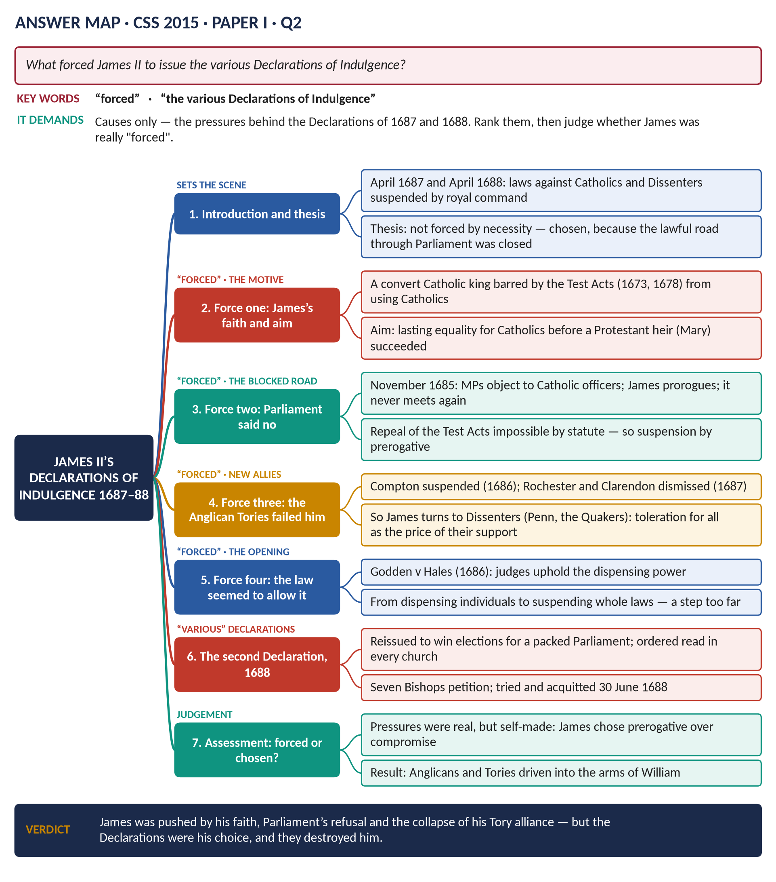
Figure 1 · The answer map for CSS 2015 · Q2 · Paper I: every branch is one heading of the answer below.
DECODING THE QUESTION
The key word is "forced". The examiner wants the pressures and motives behind the Declarations of 1687 and 1688 ("the various Declarations"), ranked — and a judgement on whether James was really forced or chose. Describing the Declarations is only the starting point; the marks are in the causes.

The model answer

(1) Introduction: a choice that looked like necessity
In April 1687, and again in April 1688, James II used his royal prerogative to suspend every law that punished Catholics and Protestant Dissenters, including the Test Acts of 1673 and 1678. These Declarations of Indulgence were the most important — and most fatal — acts of his reign. James was not "forced" to issue them in the sense that he had no alternative. He was driven by his Catholic faith and aims, and pushed towards prerogative action because every lawful road — Parliament, the Tory alliance, the Church — had been closed to him, partly by his own conduct.

(2) What the Declarations were

(i) The Declaration of 4 April 1687
- Suspended "the execution of all and all manner of penal laws in matters ecclesiastical".
- Allowed Catholics and Dissenters to worship publicly.
- Declared that no religious test should be required for office.
- A Scottish version had been issued in February 1687.

(ii) The Declaration of 27 April 1688
- Repeated the first, with a promise to call Parliament by November 1688.
- On 4 May the clergy were ordered to read it from every pulpit — the order that produced the case of the Seven Bishops.

(3) The first pressure: James's faith and his aim

(i) A Catholic king barred by law
James had become a Catholic in about 1669 and had resigned as Lord High Admiral rather than take the Test in 1673. As king he could not legally appoint his co-religionists to office, the army or Parliament. To a convert who believed his faith was true, this was intolerable.

(ii) A race against time
James was fifty-one in 1685. Until June 1688 his heirs were his Protestant daughters, Mary and Anne. Whatever he achieved for Catholics had to be made permanent before he died. A Declaration could be issued at once; an Act of Parliament could not.

(4) The second pressure: Parliament refused
- In November 1685, after Monmouth's rebellion, the loyal Parliament voted money but objected to the Catholic officers James had commissioned in breach of the Test Act.
- James prorogued it; it never met again and was dissolved in July 1687.
- The lawful route — repeal of the Test Acts by statute — was therefore blocked. The Declaration was a substitute for legislation.

(5) The third pressure: the Tory–Anglican alliance collapsed

(i) James lost his natural allies
The Tories and the Church had saved James's right to the throne in the Exclusion Crisis. But they would not help him dismantle the Church's monopoly. James responded by attacking them: the Ecclesiastical Commission suspended Bishop Compton (1686); Magdalen College was purged (1687); and his Anglican brothers-in-law, Rochester and Clarendon, were dismissed in January 1687 — three months before the first Declaration.

(ii) So he sought new allies — the Dissenters
A Declaration that gave freedom to all non-Anglicans, not just Catholics, could win the Protestant Dissenters (Presbyterians, Baptists, Quakers such as William Penn) to the king's side. The Declaration was thus a political alliance as much as a religious policy: toleration was the price of their votes.

(6) The fourth pressure: the law seemed to allow it
In Godden v Hales (June 1686) the judges ruled eleven to one that the king could dispense individuals from the penal laws. James read this as a green light. But there is a large difference between dispensing one man and suspending the law for everyone — a power Parliament had condemned when Charles II tried it in 1672–73.

(7) Why the Declaration was reissued in 1688
- James planned to pack a Parliament: the "Three Questions" to magistrates, the purge of hundreds of JPs and the remodelling of town corporations.
- Reissuing the Declaration, and making the clergy read it, was a campaign for the coming elections — and a test of loyalty.
- It backfired: Archbishop Sancroft and six bishops petitioned; they were tried and acquitted on 30 June 1688 — the same night William was invited.
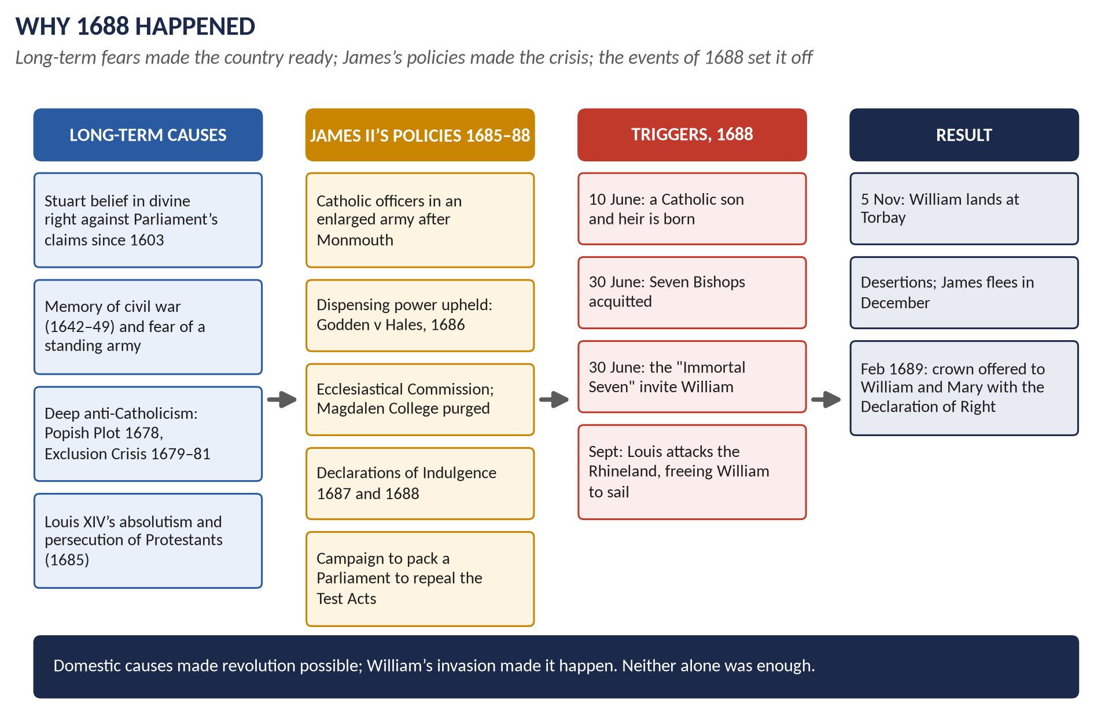
Figure 2 · The chain from James's policies to revolution. The Declarations sit at the centre of the second column.

(8) Assessment: forced, or chosen?
Pressure | How strong? | Was it of James's own making?
Faith and the aim of Catholic equality | Very strong — the root motive | His own conviction
Parliament's refusal (1685) | Strong — closed the lawful route | Partly: he chose prorogation over compromise
Loss of Tory–Anglican support | Strong — made Dissenters necessary | Largely: his attacks on the Church caused it
Godden v Hales | Moderate — an enabling excuse | Yes: he replaced judges to win it
Time (age, Protestant heirs) | Strong until June 1688 | No

The pressures were real, but most of them were self-made. A more patient king could have used his dispensing power quietly, case by case. James chose the broadest possible weapon — the suspending power — and so turned a religious question into a constitutional one.

(9) Conclusion
James II was pushed towards the Declarations of Indulgence by his faith, by the refusal of Parliament, by the collapse of his Tory–Anglican alliance and by the shortness of time. But he was not forced: the Declarations were his choice, made because he preferred prerogative to compromise. They united Whigs, Tories and the Church against him and led directly to the Seven Bishops, the Invitation and the Revolution. In seeking to secure toleration by royal power, James destroyed both.
WHY THIS ANSWER SCORES
The thesis answers the key word "forced" in the first paragraph and returns to it in the assessment table. Both Declarations ("various") are covered. Each pressure is dated and evidenced, and the answer distinguishes dispensing from suspending — the constitutional point examiners look for.

Answer 2 · The Causes of the Glorious Revolution
THE QUESTION · CSS 2018 · Q2 · Section A · 20 marks
What led to the occurrence of the ultra-degree of mega development towards the close of the 17th century in Britain known as the 'Glorious Revolution'?

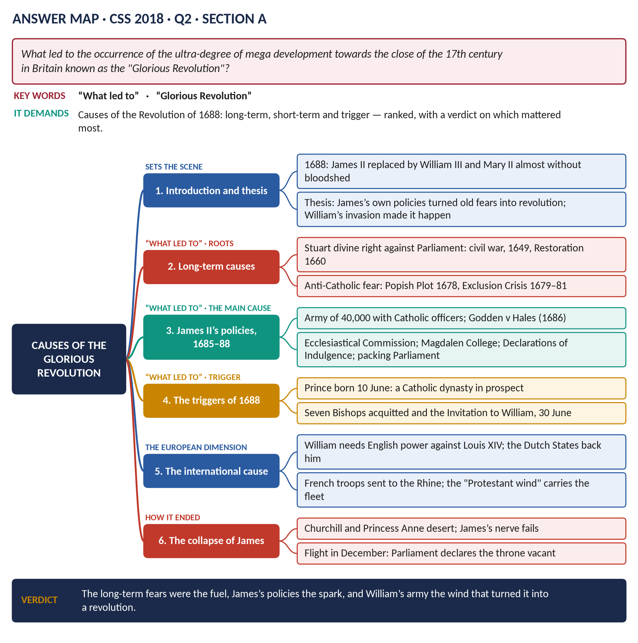
Figure 3 · The answer map for CSS 2018 · Q2 · Section A: every branch is one heading of the answer below.
DECODING THE QUESTION
Strip away the unusual wording ("ultra-degree of mega development"): this is a causes question — "What led to" the Revolution of 1688. A top answer ranks the causes into long-term, short-term and trigger, adds the European cause (William and Louis XIV), and ends with a verdict on which mattered most.

The model answer

(1) Introduction
Between November 1688 and February 1689 James II lost his throne to his nephew and son-in-law, William of Orange, who reigned jointly with his wife Mary II. The change was made with little bloodshed in England and was followed by the Bill of Rights (1689), which permanently limited the Crown. The Revolution had deep roots in seventeenth-century fears of popery and arbitrary government, but it was James's own policies that turned those fears into revolution, and William's invasion, launched for European reasons, that made it happen.

(2) Long-term causes

(i) Crown against Parliament since 1603
The Stuarts believed in the divine right of kings; Parliament believed in the rule of law and its control of taxation. The conflict had produced the Civil War (1642–49), the execution of Charles I (1649) and Cromwell's military rule. The Restoration of 1660 left the balance of power unsettled.

(ii) Anti-Catholicism
To most English Protestants Catholicism meant tyranny and foreign power. The Popish Plot (1678) and the Exclusion Crisis (1679–81), when the Whigs tried to bar James from the throne, showed how deep the fear ran. The revocation of the Edict of Nantes by Louis XIV in 1685 gave it fresh proof.

(iii) Fear of a standing army
The memory of Cromwell's army made Parliament hostile to any large permanent force under royal control.

(3) The main cause: James II's policies, 1685–88

(i) The army and Catholic officers
After Monmouth's rebellion (1685) James enlarged the army to some 34,000 in England, camped it at Hounslow Heath and commissioned Catholic officers despite the Test Acts.

(ii) The dispensing and suspending powers
Godden v Hales (1686) upheld the dispensing power after James had replaced reluctant judges. The Declarations of Indulgence (1687, 1688) suspended the penal laws altogether.

(iii) Attacks on the Church of England
The Ecclesiastical Commission suspended Bishop Compton (1686); Magdalen College, Oxford, was given a Catholic president and its Fellows were expelled (1687).

(iv) Attacks on local government and property
The "Three Questions" and the purge of JPs, Lords Lieutenant and town corporations (1687–88) were meant to pack a Parliament. They threatened the gentry's control of their counties — and their property.
KEY IDEA · Why these policies were decisive
They turned James's natural supporters — the Tories and the Church, who believed in obedience to the king — into his opponents. A revolution needed the political class to abandon the king. James made them do so.

(4) The triggers of 1688
- 10 June: the birth of James Francis Edward. James's policies would now be continued by a Catholic dynasty; the Protestant Mary would never succeed.
- 30 June: the Seven Bishops were acquitted — proof that law and opinion were against the king.
- 30 June: the "Immortal Seven" — Danby, Devonshire, Shrewsbury, Lumley, Compton, Russell and Sydney — invited William to intervene.

(5) The European cause: William and Louis XIV
- William's aim was to bring England into the coming war against Louis XIV, and to prevent an Anglo-French alliance.
- In September 1688 Louis sent his army to the Rhineland (Philippsburg), not against the Dutch. The States-General backed William's expedition.
- Revisionist historians (J. R. Jones, Jonathan Israel) stress that without this Dutch invasion there would have been no revolution in 1688.

(6) The collapse of James
William landed at Torbay on 5 November 1688. Risings followed in the north and Midlands; James's officers, led by John Churchill, deserted at Salisbury; his daughter Anne joined the rebels. James lost his nerve and fled (11 and finally 23 December). A Convention declared that he had abdicated and that the throne was vacant.
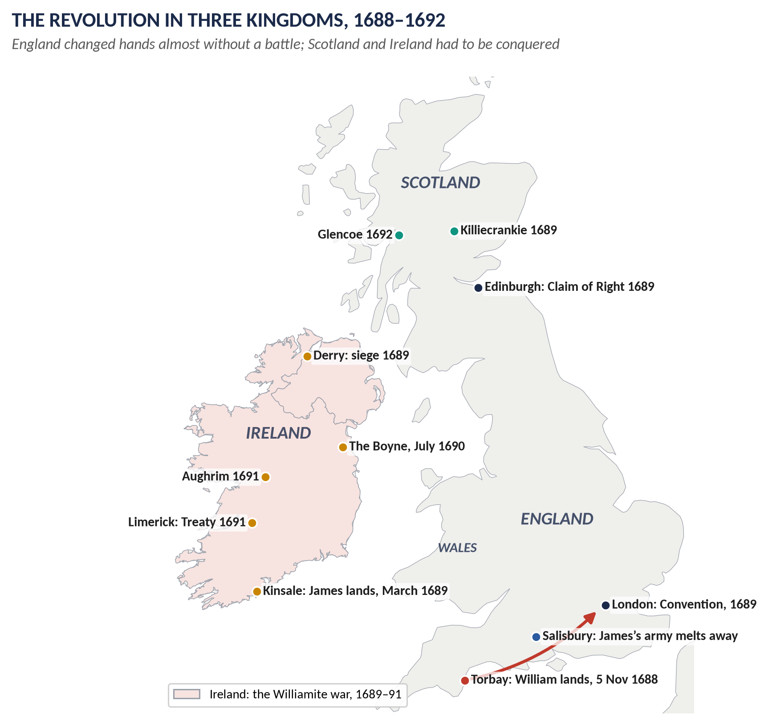
Figure 4 · Where the Revolution happened, 1688–92: William's march from Torbay, and the wars that followed in Scotland and Ireland.

(7) Weighing the causes
Cause | Role | Weight
Long-term fears (divine right, popery, army) | Made the political nation ready to act | Necessary but not sufficient
James's policies 1685–88 | United Whigs and Tories against him | The main cause
Birth of the heir; the bishops | Turned grievance into urgency | The trigger
William's invasion and Louis's move | Supplied the force | Decisive for timing and success
James's collapse of nerve | Ensured no civil war | Explains why it was "glorious"

(8) Conclusion
The Glorious Revolution happened because long-standing fears of popery and arbitrary government were brought to life by James II's policies, made urgent by the birth of a Catholic heir, and carried through by William of Orange's invasion for reasons of European strategy. James's policies were the essential cause: they destroyed the loyalty of the Tories and the Church, without which no Stuart king could survive. But without William's army, England's discontent might have waited for James's death. The long-term fears were the fuel, James the spark, and William the wind.
WHY THIS ANSWER SCORES
It decodes the odd wording at once and answers "what led to" with a clear ranking. The European dimension (Louis's move to the Rhine; the Dutch invasion) is what lifts it above the standard narrative, and the table shows the examiner the weighing the question requires.

Answer 3 · How the Glorious Revolution Occurred — and Its Fallout
THE QUESTION · CSS 2023 · Q2 · Section A · 20 marks
How did the Glorious Revolution occur in Britain? What was its fallout at home and abroad?

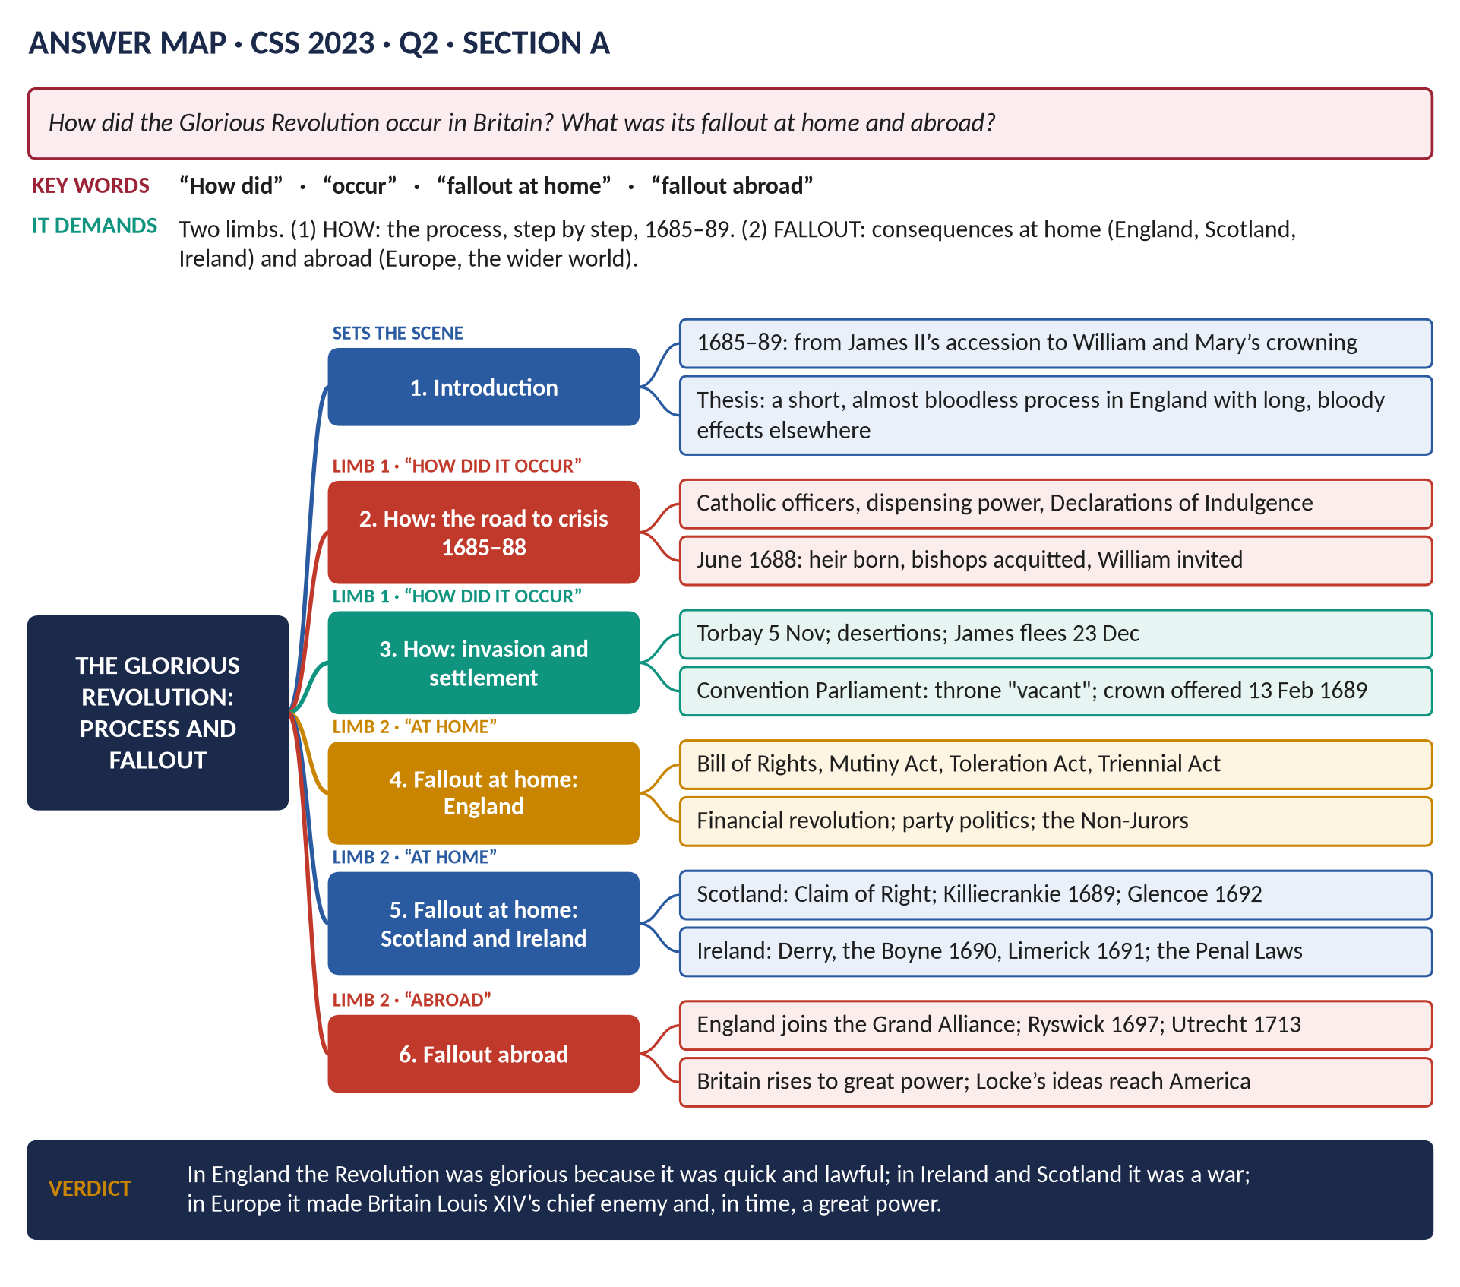
Figure 5 · The answer map for CSS 2023 · Q2 · Section A: every branch is one heading of the answer below.
DECODING THE QUESTION
Two limbs. "How did it occur?" asks for the process, step by step, from James's policies to the settlement of 1689 — not a list of causes. "What was its fallout at home and abroad?" asks for consequences in England, Scotland and Ireland (home) and in Europe and the wider world (abroad). Give the second limb at least half the answer.

The model answer

(1) Introduction
The Glorious Revolution of 1688–89 replaced the Catholic James II with the Protestant William III and Mary II. In England it was quick and almost bloodless, carried out by an invasion, a collapse and a parliamentary settlement. Its fallout was far wider: it made Parliament permanent, created a new financial system, brought war to Scotland and Ireland, and turned England into the leading enemy of Louis XIV — and, in time, a great power.

Limb one — how the Revolution occurred

(2) Stage one: James alienates the nation (1685–88)
- 1685: after crushing Monmouth at Sedgemoor, James keeps a large army with Catholic officers.
- 1686: Godden v Hales upholds the dispensing power; the Ecclesiastical Commission suspends Bishop Compton.
- 1687: the Declaration of Indulgence suspends the penal laws; Magdalen College is purged; the Tory Hyde brothers are dismissed.
- 1687–88: the attempt to pack Parliament through the "Three Questions" and purges of local officials.

(3) Stage two: the crisis of 1688
- April–May: the Declaration is reissued and ordered read in churches; the Seven Bishops petition and are sent to the Tower.
- 10 June: a Catholic heir, James Francis Edward, is born.
- 30 June: the bishops are acquitted; the Immortal Seven invite William.
- September: Louis XIV attacks the Rhineland; the Dutch back William.

(4) Stage three: invasion and collapse
- 5 November: William lands at Torbay with about 15,000 men.
- November: risings at York and Nottingham; desertions at Salisbury (John Churchill); Princess Anne joins the rebels.
- 11 December: James flees and is caught; 23 December: he escapes to France.

(5) Stage four: the settlement
- 22 January 1689: the Convention meets.
- 28 January: the Commons resolve that James has "abdicated" and the throne is "vacant".
- 13 February: William and Mary accept the crown jointly and hear the Declaration of Right, which becomes the Bill of Rights in December.

Limb two — the fallout at home

(6) England: a new constitution

(i) The Revolution Settlement
- Bill of Rights (1689): no suspending power; no taxation or peacetime army without Parliament; no Catholic monarch.
- Mutiny Act (1689): the army legal for one year at a time — so Parliament must meet every year.
- Toleration Act (1689): freedom of worship for Protestant Dissenters.
- Triennial Act (1694); Act of Settlement (1701).

(ii) The Financial Revolution
War with France forced new finance: the land tax (1692), the Bank of England (1694) and a permanent National Debt guaranteed by Parliament.

(iii) Politics and the Church
- The Whig–Tory "rage of party" became the stuff of annual parliaments; the press became free (1695).
- The Non-Jurors — Archbishop Sancroft and about 400 clergy — refused the new oaths and were deprived.

(7) Scotland and Ireland: revolution by war
Kingdom | Fallout
Scotland | Claim of Right (1689): James "forfeited" the crown; bishops abolished, Presbyterian Kirk restored (1690); Jacobite victory but loss of Dundee at Killiecrankie (1689); the Glencoe massacre (1692); lasting Jacobitism
Ireland | James lands at Kinsale (1689); siege of Derry; the Boyne (1690), Aughrim and Limerick (1691); the Penal Laws exclude Catholics from land, office and the professions; Protestant Ascendancy for a century

Limb two — the fallout abroad

(8) Europe and the wider world
1. England enters the war against Louis XIV (May 1689) and joins the Grand Alliance; the Nine Years' War ends at Ryswick (1697), where Louis recognises William.
2. The Spanish Succession war (1702–13) follows; at Utrecht (1713) Britain gains Gibraltar and Minorca, and France recognises the Protestant succession.
3. The balance of power becomes the guiding principle of British policy for two centuries.
4. Britain becomes a great power, built on credit, the navy and trade.
5. Ideas travel: Locke's Two Treatises (1689) justified resistance to tyranny; the American colonists cited 1688 in 1776.
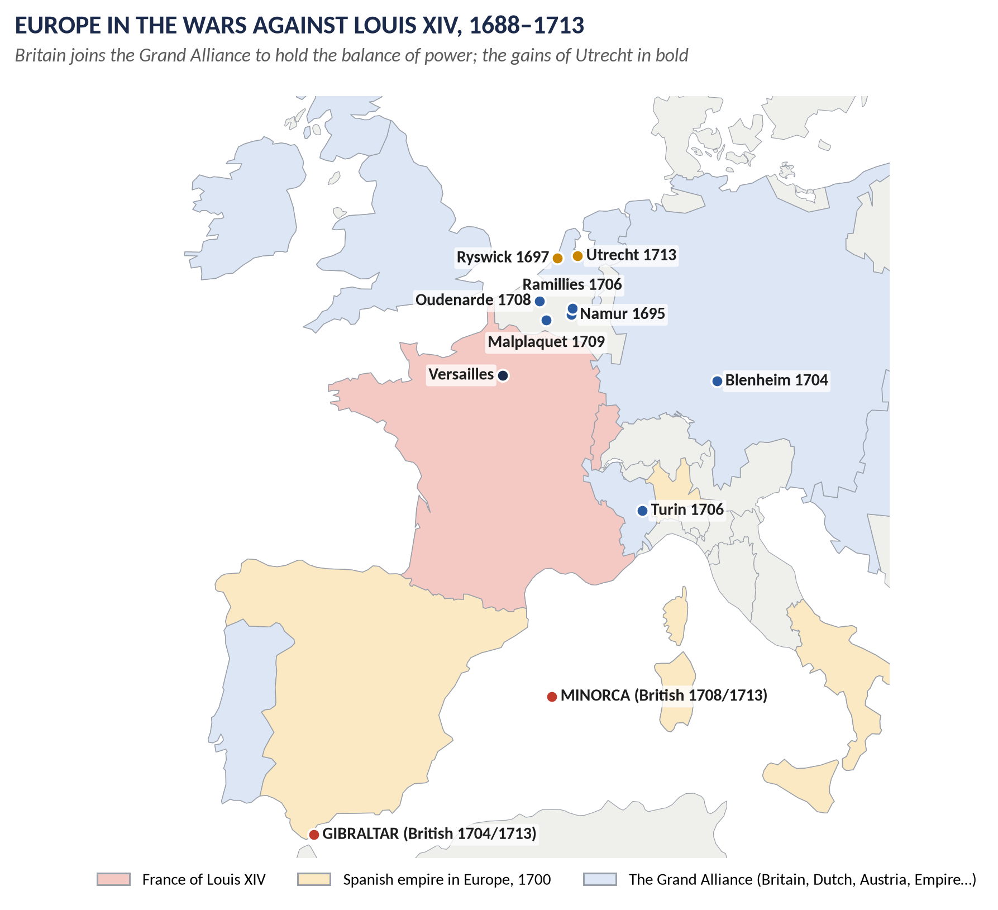
Figure 6 · The fallout abroad: Britain in the Grand Alliance against Louis XIV, 1688–1713.

(9) Assessment
At home in England the Revolution was a quick change of ruler followed by a lasting change of system: the monarch now needed Parliament every year. In Scotland and Ireland it was a war, and in Ireland a conquest followed by persecution. Abroad it was a diplomatic revolution: England switched from a potential French ally to Louis XIV's most determined enemy.

(10) Conclusion
The Revolution occurred through James's alienation of the political nation, the crisis of June 1688, William's invasion and James's collapse, and a parliamentary settlement. Its fallout was constitutional and financial at home, violent in Scotland and Ireland, and transformative abroad, where it made Britain a great power and the keeper of the European balance.
WHY THIS ANSWER SCORES
The answer mirrors the question's two limbs with separate headed sections, and splits "home" into England, Scotland and Ireland — which most candidates forget. Dated steps show "how"; the table and the map make the "fallout" concrete.

Answer 4 · What Was So Glorious About the Glorious Revolution?
THE QUESTION · CSS 2019 · Q2 · Section A · 20 marks
What was so glorious about the Glorious Revolution? Discuss its significance in British history.

Figure 7 · The answer map for CSS 2019 · Q2 · Section A: every branch is one heading of the answer below.
DECODING THE QUESTION
Two limbs. "What was so glorious?" asks you to explain the label — and, because the word "so" invites scepticism, to test it. "Discuss its significance in British history" asks for its long-term importance. The answer map (above) shows the plan: branch 2 and branch 6 answer limb one; branches 4 and 5 answer limb two.

The model answer

(1) Introduction and thesis
In 1688–89 the Catholic James II fled to France and Parliament gave his crown to William III and Mary II, with a Declaration of Right that limited royal power. The Whigs called it "glorious" at once. The label was partly propaganda — the Revolution was bloody in Ireland and Scotland, and it began as a Dutch invasion — but it was deserved in one fundamental sense: it settled, by law, that the Crown must govern with and under Parliament. That is its lasting significance.

(2) Why "glorious" — the case for the label

(i) Almost bloodless in England
William landed at Torbay on 5 November 1688. James's army of some 30,000 melted away; his commanders, including John Churchill, deserted; he fled in December. There was no battle in England. To a generation that remembered the Civil War, this was the chief glory.

(ii) Achieved by law, not by the sword
A Convention met, debated, and resolved that James had "abdicated". The crown was offered to William and Mary on 13 February 1689 with the Declaration of Right. The new monarchy rested on a parliamentary title.

(iii) "Conservative" — restoring, not overturning
Its makers claimed to restore the ancient constitution and to protect the Protestant religion, not to create something new. Society, property and the Church were untouched.

(3) The Revolution Settlement, 1689–1701 — the bridge to significance
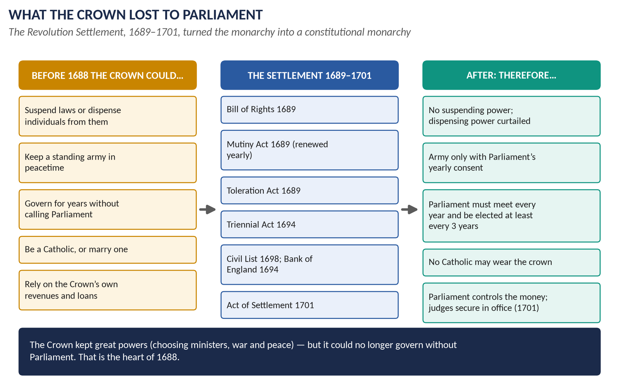
Figure 8 · What the Crown lost to Parliament, 1689–1701.
- Bill of Rights (1689): no suspending power; no taxes or peacetime army without Parliament; no Catholic monarch.
- Mutiny Act (1689) and annual money grants: Parliament must meet every year.
- Toleration Act (1689); Triennial Act (1694); Act of Settlement (1701).

(4) Significance at home

(i) The end of divine-right monarchy
After 1689 the monarch held the crown by Act of Parliament. The Stuart claim to rule by divine right was finished; constitutional monarchy began.

(ii) Parliament becomes permanent
Because the army and taxes were voted for short periods, Parliament met every year from 1689 — and has done so ever since. Party politics (Whig and Tory) and, later, cabinet government grew from this.

(iii) The Financial Revolution
The Bank of England (1694) and the National Debt allowed Britain to borrow cheaply because lenders trusted a Parliament of property-owners. This "fiscal-military state" (John Brewer) paid for a century of wars.

(5) Significance beyond England
1. Europe: England joined the wars against Louis XIV (1689–97, 1702–13) and rose to great-power status at Utrecht (1713).
2. Scotland and Ireland: the Revolution meant Killiecrankie and Glencoe in Scotland and the Boyne (1690) and the Penal Laws in Ireland — the roots of Jacobitism and of the Irish Question (Topics 2, 3 and 5).
3. Ideas: John Locke's Two Treatises (1689) argued that government rests on consent; the American colonists used 1688 to justify their own revolution in 1776.

(6) How glorious? The critical view
Criticism | Evidence
A Dutch invasion, not a national rising | 15,000 foreign troops; planned in The Hague for European reasons (J. R. Jones, J. Israel)
Liberty for Protestant men of property only | Catholics excluded from the throne and office; only about one man in five could vote (C. Hill)
Not glorious outside England | War in Ireland and Scotland; the Penal Laws; Glencoe (T. Harris)
Not bloodless even in intention | James might have fought; William came ready for war

Against this, Macaulay called it "of all revolutions the least violent" and "the most beneficent", and Steve Pincus (2009) argues it was a genuine and popular "first modern revolution".

(7) Conclusion
The Revolution was "glorious" to its makers because it was quick, lawful and nearly bloodless in England, and because it saved Protestantism and the ancient constitution. The critics are right that it was neither bloodless everywhere nor liberal for all. But its significance in British history is beyond doubt: by statute it made the Crown govern with and under Parliament, created the financial power of the British state, and set the frame within which every later reform — from Walpole's cabinet to the Reform Acts — took place.
WHY THIS ANSWER SCORES
Each limb gets its own headings; the word "so" is answered by testing the label, not just praising it. Named historians on both sides give balance, and the settlement figure links the "glory" to the "significance" — which is exactly how the question is built.

Answer 5 · Non-Jurors, High Churchmen and Latitudinarians
THE QUESTION · CSS 2021 · Q2 · Section A · 20 marks
What were the political and ideological differences among Non-Jurors, High Churchmen and Latitudinarians?

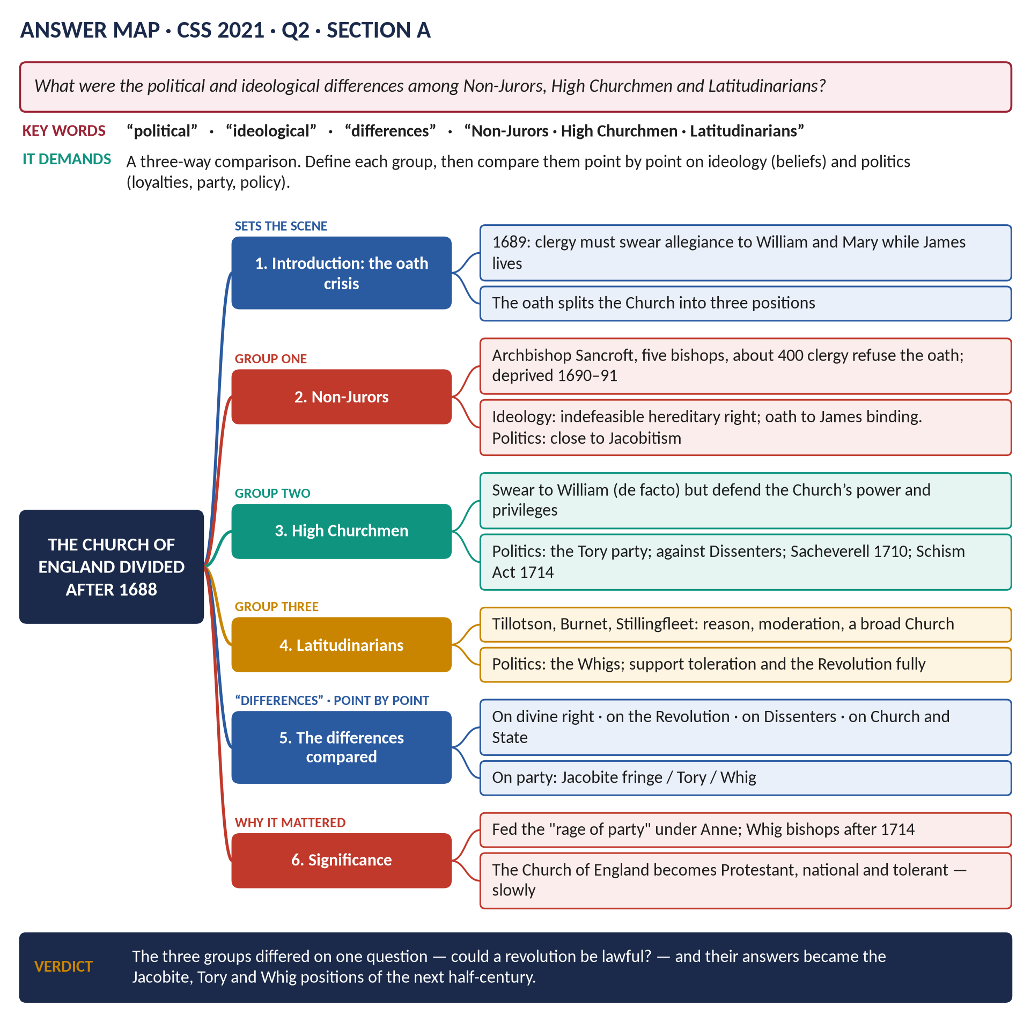
Figure 9 · The answer map for CSS 2021 · Q2 · Section A: every branch is one heading of the answer below.
DECODING THE QUESTION
A three-way comparison with two named dimensions: political (loyalties, party, attitude to the new regime and to Dissenters) and ideological (beliefs about kingship, obedience and the Church). Define each group briefly, then compare point by point — the comparison is where the marks are.

The model answer

(1) Introduction: one oath, three answers
The Revolution of 1688–89 posed a painful question to the Church of England. For a generation it had taught passive obedience and the indefeasible hereditary right of kings. In 1689 every clergyman had to swear allegiance to William and Mary while James II, the anointed king, was still alive. The Church divided into three: the Non-Jurors, who refused; the High Churchmen, who swore reluctantly but defended the Church's privileges; and the Latitudinarians, who welcomed the Revolution. Their differences were, at bottom, one question: could a revolution be lawful?

(2) The Non-Jurors

(i) Who they were
Archbishop William Sancroft of Canterbury, five other bishops — among them Thomas Ken of Bath and Wells — and about 400 clergy. Several had been among the Seven Bishops who defied James in 1688. They were deprived of their posts in 1690–91.

(ii) Their ideology
- Kingship is sacred and hereditary; no Parliament can make or unmake a king.
- An oath is binding before God: they had sworn allegiance to James.
- The Church is a spiritual society; the State had no right to deprive its bishops.

(iii) Their politics
- They rejected the Revolution as unlawful, though most did not actively plot.
- They were the natural allies of the Jacobites, and kept up a separate line of bishops into the late 18th century.

(3) The High Churchmen

(i) Who they were
The majority of parish clergy and the Tory gentry; leaders such as Francis Atterbury and, later, Henry Sacheverell.

(ii) Their ideology
- They took the oath by treating William as king de facto (in fact) or by providence, not by the people's right to choose.
- They held to the Church's divine authority, the role of bishops and Convocation, and the privileged position of the Church in the State.

(iii) Their politics
- The Tory party's religious wing: "the Church in danger".
- Hostile to Dissenters and to "occasional conformity" (Dissenters taking Anglican communion to qualify for office).
- Their triumphs: the Sacheverell trial (1710), the Occasional Conformity Act (1711) and the Schism Act (1714).

(4) The Latitudinarians

(i) Who they were
John Tillotson (Archbishop of Canterbury, 1691–94), Gilbert Burnet (Bishop of Salisbury), Edward Stillingfleet, Thomas Tenison — the men William appointed to the sees left empty by the Non-Jurors.

(ii) Their ideology
- "Latitude" — breadth: reason, morality and moderation mattered more than disputed doctrine or forms of worship.
- Government rests on a contract, or at least on the needs of the Protestant religion; resistance to a tyrant could be lawful.
- A broad national Church that could "comprehend" moderate Dissenters.

(iii) Their politics
- The Whigs' allies; enthusiastic supporters of the Revolution and of toleration.
- They backed the failed Comprehension Bill (1689) and the Toleration Act (1689).

(5) The differences compared
Point | Non-Jurors | High Churchmen | Latitudinarians
The oath (1689) | Refused | Took it, reluctantly | Took it gladly
Divine right | Indefeasible — still James's | Held, but bent to accept William de facto | Played down; contract and providence
The Revolution | Unlawful | Accepted, uneasily | Lawful and providential
Dissenters | Hostile | Hostile; restrict them | Tolerate; include them
Church and State | Church independent of the State | Church privileged by the State | Church serving a Protestant State
Party | Jacobite fringe | Tory | Whig
Fortune | Deprived; faded | Strong in parishes; defeated after 1714 | Bishops after 1689 and after 1714

(6) Significance
- Party politics: the religious split fed the "rage of party" under Anne. Religion was the deepest divide between Whig and Tory.
- Jacobitism: the Non-Jurors gave the exiled Stuarts a moral and religious cause.
- The long run: after 1714 the Whigs filled the bishops' bench with moderates; the Church became Protestant, national and tolerant — slowly, and never for Catholics until 1829.

(7) Conclusion
The three groups differed ideologically on whether kingship was sacred and hereditary or rested on law and consent, and politically on whether to accept the Revolution, how to treat Dissenters, and which party to support. The Non-Jurors refused the new order, the High Churchmen accepted its king but fought its toleration, and the Latitudinarians embraced it. Between them they mapped out the Jacobite, Tory and Whig positions of the next half-century.
WHY THIS ANSWER SCORES
It answers both named dimensions — political and ideological — for each group, then compares them point by point in a table, which is what a "differences" question demands. Specific names, dates and laws (1689, 1690–91, 1710, 1711, 1714) turn a theological topic into history.

Answer 6 · The War of the League of Augsburg and the Treaty of Ryswick
THE QUESTION · CSS 2015 · Q3 · Paper I · 20 marks
Account for the War of the League of Augsburg followed by the Treaty of Ryswick.

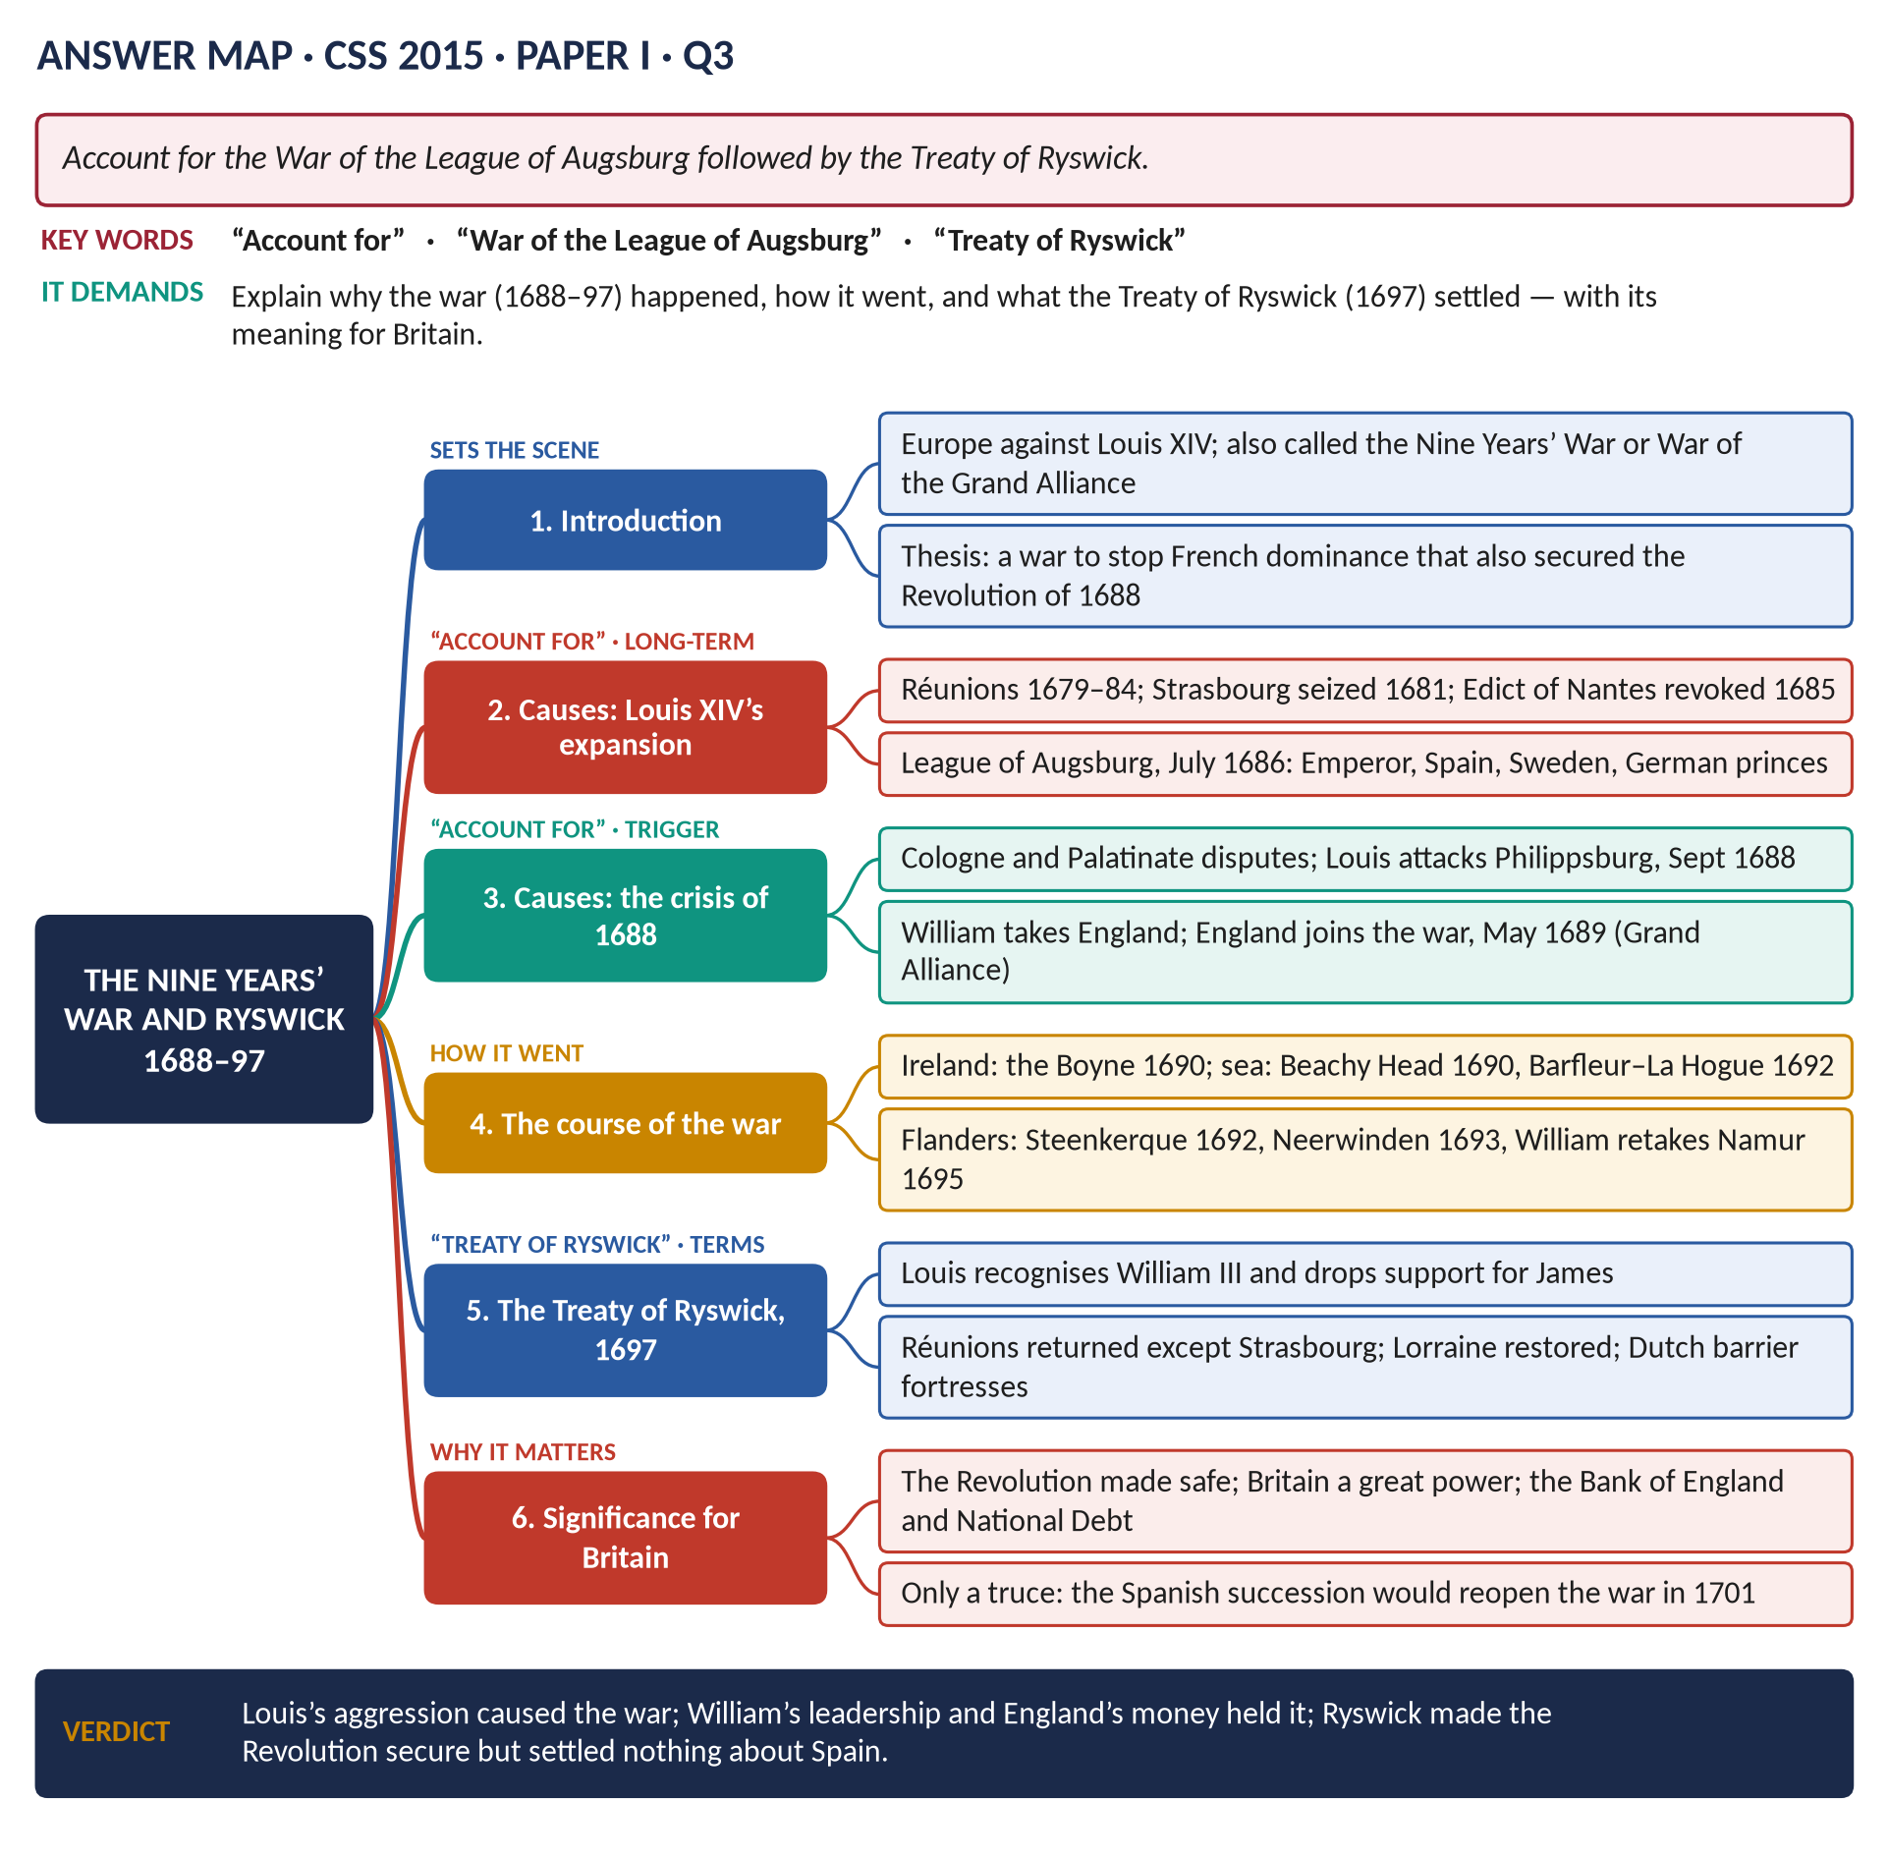
Figure 10 · The answer map for CSS 2015 · Q3 · Paper I: every branch is one heading of the answer below.
DECODING THE QUESTION
"Account for" means explain why it happened — the causes are the core. "Followed by the Treaty of Ryswick" adds the settlement: its terms and meaning. Include the course of the war briefly, and end with the significance for England/Britain.

The model answer

(1) Introduction
The War of the League of Augsburg — also called the Nine Years' War (1688–97) or the War of the Grand Alliance — set most of Europe against Louis XIV of France. It was caused by Louis's drive to expand France's frontiers and the fear this created, and it was turned into a general war by the Revolution of 1688, which brought England in under William III. The Treaty of Ryswick (1697) checked Louis and secured the Revolution, but it left the greatest question — the Spanish succession — unresolved.

(2) The long-term causes: Louis XIV's expansion

(i) Twenty years of French aggression
- The War of Devolution (1667–68) and the Dutch War (1672–78), ended by the Treaty of Nijmegen (1678).
- The Réunions (1679–84): French courts "reunited" to France border lands in Alsace and Lorraine; Strasbourg was seized in 1681; the Truce of Ratisbon (1684) accepted these gains for twenty years.

(ii) The Protestant alarm
The revocation of the Edict of Nantes (1685) and the flight of the Huguenots turned Protestant Europe against Louis.

(iii) The League of Augsburg
In July 1686 the Emperor Leopold I, Spain, Sweden, Bavaria, Saxony and the Palatinate formed the League of Augsburg to defend the Empire's borders.

(3) The short-term causes and the trigger
1. The Palatinate: Louis claimed lands for his sister-in-law, Elizabeth Charlotte ("Liselotte"), sister of the dead Elector Palatine.
2. Cologne (1688): Louis's candidate for the archbishopric-electorate was rejected.
3. September 1688: Louis attacked Philippsburg, hoping a short war would force the Germans to accept his gains.
4. November 1688: William of Orange, freed by Louis's move east, invaded England. Louis had expected England to be paralysed by civil war; instead it joined his enemies.
5. May 1689: England declared war; the Grand Alliance (Treaty of Vienna, May 1689) united the Emperor, the Dutch and England, later joined by Spain and Savoy.

(4) The course of the war
Theatre | Events
Ireland | James II lands with French help (1689); Derry holds; William wins at the Boyne (1690); Limerick (1691)
At sea | French victory at Beachy Head (1690); Anglo-Dutch victory at Barfleur–La Hogue (1692) ends French invasion plans
The Netherlands | French victories at Fleurus (1690), Steenkerque (1692) and Neerwinden (1693); William recaptures Namur (1695)
Britain's home front | Land tax (1692); Bank of England (1694); National Debt; recoinage (1696)

By 1697 France had suffered the terrible famine of 1693–94 and was bankrupt; the allies too were exhausted.
Figure 11 · The theatre of the wars against Louis XIV: Namur and Ryswick in the Low Countries, and the powers of the Grand Alliance.

(5) The Treaty of Ryswick, September 1697
1. Louis recognised William III as King of England, Scotland and Ireland and promised not to support his enemies — abandoning James II.
2. France gave back most of the Réunions and conquests since 1678 — but kept Strasbourg.
3. Lorraine was restored to its duke.
4. The Dutch won the right to garrison barrier fortresses in the Spanish Netherlands, and a favourable trade treaty.
5. Colonial conquests in America and India were returned.

(6) The significance of the war and the treaty for Britain
- The Revolution secured: recognition by Louis made William's title part of the European order.
- A new role in Europe: England fought as a principal, and the balance of power became its guiding principle.
- The Financial Revolution: the Bank of England and the National Debt, created to pay for this war, became the foundation of British power.
- Parliament strengthened: William's need for money meant annual sessions and more parliamentary control.
- Only a truce: Ryswick ignored the Spanish succession. William's two Partition Treaties (1698, 1700) failed when Charles II of Spain left everything to Louis's grandson (1700), leading to a new war in 1702.

(7) Conclusion
The War of the League of Augsburg was caused by Louis XIV's expansion and the fears it raised in Protestant and imperial Europe, and it became a general war because the Revolution of 1688 gave William England's wealth and navy. The fighting was a costly stalemate, but the Treaty of Ryswick gave the allies what mattered most to Britain: Louis's recognition of William III and of the Revolution. It checked France without settling Europe — a truce before the greater war over Spain.
WHY THIS ANSWER SCORES
"Account for" is answered with a clear causes section in two layers (long-term and trigger); the war's course is compressed into a table; and the treaty is given both terms and significance for Britain, including the link forward to the Spanish Succession.

Answer 7 · Queen Anne, the War of the Spanish Succession and the Balance of Power
THE QUESTION · CSS 2025 · Q2 · Section A · 20 marks
Discuss the significance of Queen Anne's reign in shaping the course of the War of Spanish Succession and its impact on the balance of power in Europe.

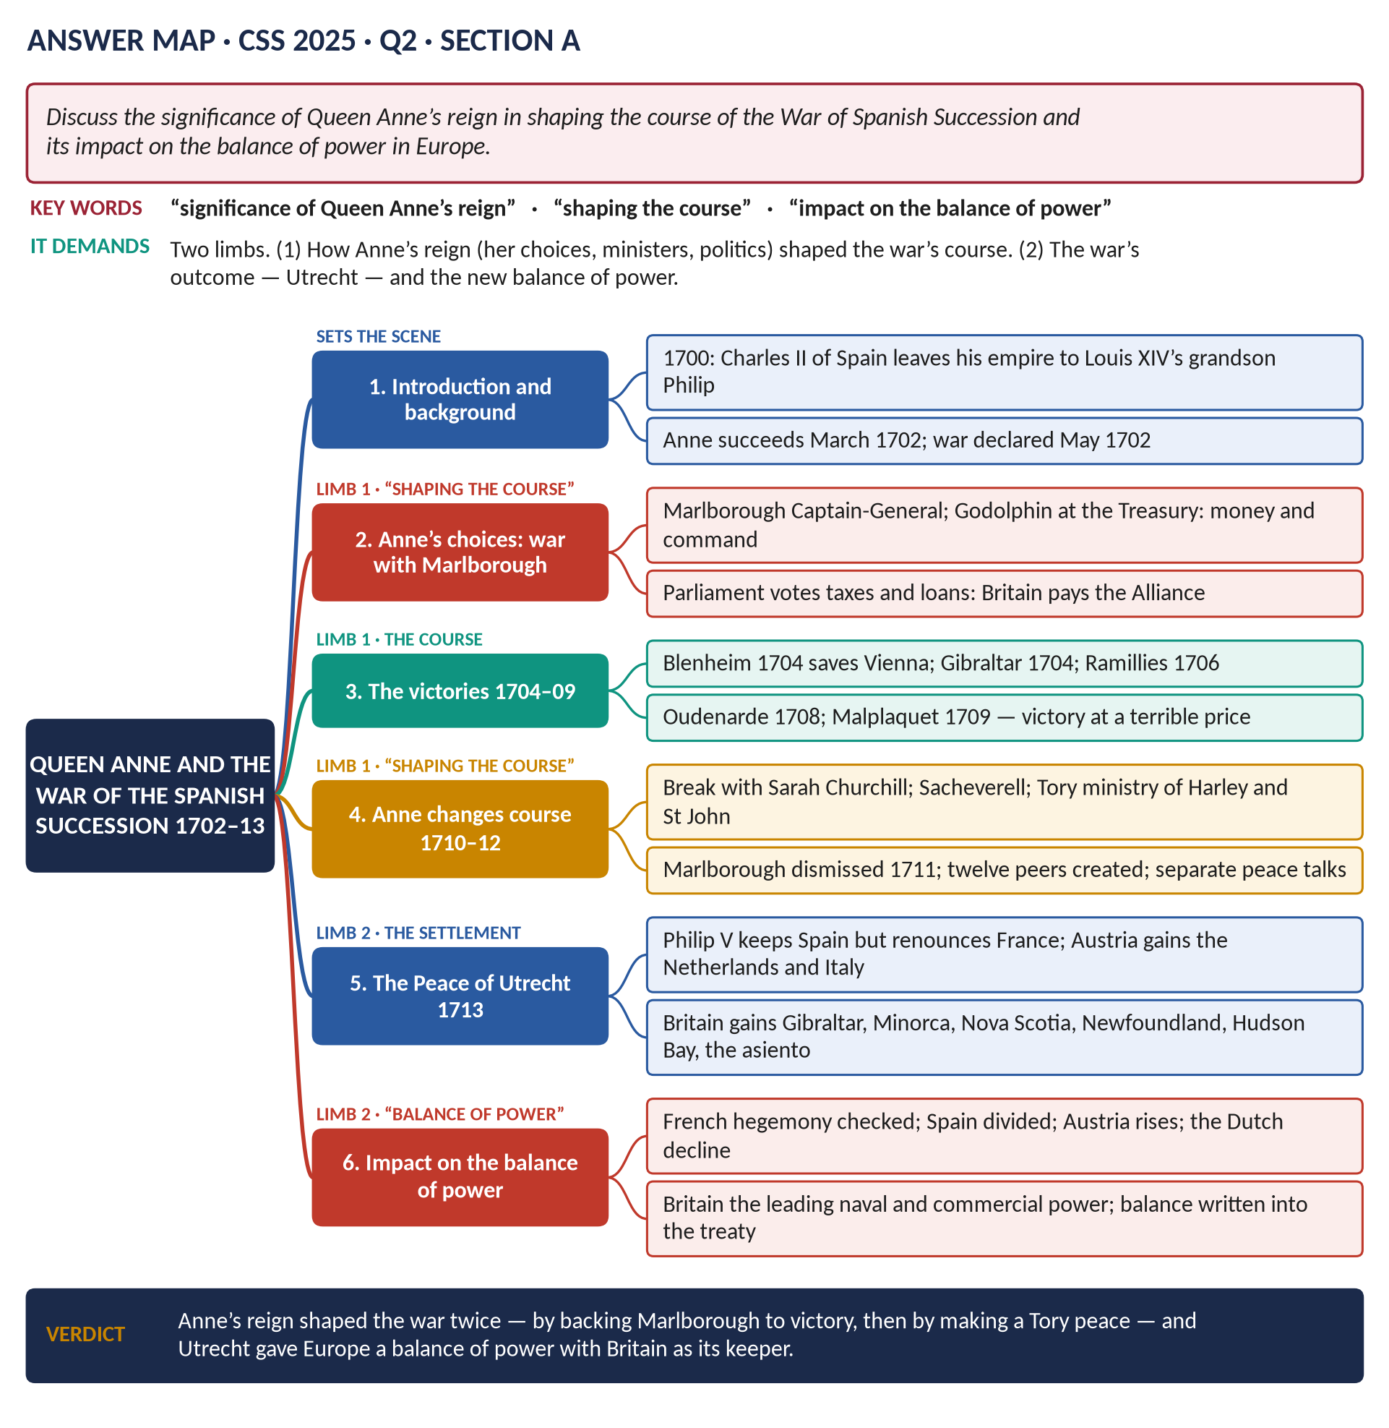
Figure 12 · The answer map for CSS 2025 · Q2 · Section A: every branch is one heading of the answer below.
DECODING THE QUESTION
Two limbs. (1) "The significance of Queen Anne's reign in shaping the course of the war" — how Anne's choices, ministers and politics steered the war: first towards victory, then towards a separate peace. (2) "Its impact on the balance of power in Europe" — the settlement of Utrecht and what it changed. Avoid a battle-by-battle narrative: every paragraph must connect to Anne's reign or to the balance of power.

The model answer

(1) Introduction
When Charles II of Spain died in 1700, he left his vast empire to Philip of Anjou, grandson of Louis XIV. A union of the French and Spanish crowns threatened to destroy the balance of power in Europe. Queen Anne, who succeeded William III in March 1702, declared war in May 1702. Her reign shaped the war twice: first by giving Marlborough the political and financial backing to win it, and then, after 1710, by turning to the Tories to end it on British terms. The Peace of Utrecht (1713) that resulted created a new European balance with Britain as its keeper.

(2) Why the war came
1. Louis accepted the will, and kept Philip's right to the French throne.
2. French troops occupied the barrier fortresses in the Spanish Netherlands (1701); French merchants took the Spanish asiento — a threat to Anglo-Dutch trade.
3. On the death of James II (September 1701) Louis recognised his son as "James III", defying the Act of Settlement.
4. The Grand Alliance of Britain, the Dutch and the Emperor was renewed at The Hague (September 1701).

(3) How Anne's reign shaped the course of the war: phase one, 1702–1709

(i) Her choice of men
Anne made her friend's husband John Churchill, Duke of Marlborough, Captain-General, and Sidney Godolphin Lord Treasurer. This "duumvirate" joined military command to financial control — the combination that won the war.

(ii) Money
Anne's Parliaments voted the land tax and loans; the Bank of England and the National Debt let Britain pay its own armies and subsidise its allies.

(iii) The victories
- Blenheim (13 August 1704): with Prince Eugene, Marlborough destroyed a Franco-Bavarian army, saved Vienna and knocked Bavaria out of the war.
- Gibraltar (1704) and Minorca (1708): Mediterranean sea power.
- Ramillies (1706): the Spanish Netherlands conquered; Oudenarde (1708).
- Malplaquet (1709): a victory that cost some 20,000 allied casualties and made the war unpopular.

(4) How Anne's reign shaped the course of the war: phase two, 1710–1713
1. "No peace without Spain": the Whig demand that Louis help expel his grandson from Spain wrecked the peace talks of 1709.
2. Anne's break with the Whigs: her quarrel with Sarah Churchill, the Sacheverell trial (1710) and a Tory landslide in October 1710.
3. The Tory ministry of Harley and St John opened secret talks with France (1711).
4. Marlborough dismissed (December 1711); twelve Tory peers created to pass the peace through the Lords.
5. The "restraining orders" (1712): the British army stood aside while the allies fought — "perfidious Albion" to Europe.
KEY IDEA · The point the question wants
Anne's reign did not only host the war — it decided its direction twice: her backing of Marlborough made victory possible; her turn to the Tories made a British-led compromise peace instead of the total victory the Whigs demanded.

(5) The Peace of Utrecht, 1713 (and Rastatt, 1714)
Power | Result
Spain | Philip V keeps Spain and America but renounces the French throne
France | Recognises the Protestant succession; expels "James III"; demolishes Dunkirk's fortifications
Austria | Gains the Spanish Netherlands, Milan, Naples and Sardinia (Rastatt, 1714)
Savoy | Gains Sicily and a crown
Britain | Gibraltar, Minorca, Newfoundland, Nova Scotia, Hudson Bay, St Kitts; the asiento for 30 years

Figure 13 · Europe before Utrecht: France, the Spanish empire and the Grand Alliance, with the Mediterranean bases Britain kept.

(6) The impact on the balance of power
1. French hegemony ended: the crowns of France and Spain were kept apart for ever.
2. Spain partitioned: its European empire passed to Austria and Savoy; Spain became a second-rank power.
3. Austria rose as the dominant power in Italy and the Low Countries.
4. The Dutch declined, exhausted by two long wars.
5. Britain rose as the leading naval and commercial power, with Mediterranean bases, North American territory and access to Spanish-American trade.
6. The principle of a "just equilibrium of power" was written into the Anglo-Spanish treaty and guided British policy until 1914.

(7) Conclusion
Anne's reign was decisive for the War of the Spanish Succession. By trusting Marlborough and Godolphin, she gave the Grand Alliance its greatest victories; by turning to Harley and St John after 1710, she ended the war on terms that suited Britain rather than her allies. The Peace of Utrecht broke the threat of a Franco-Spanish super-power, divided Spain's empire, and made the balance of power — with Britain as its maritime guardian — the rule of European politics for a century.
WHY THIS ANSWER SCORES
Both limbs get their own headed sections; the reign is shown shaping the war twice, which is the insight the question rewards. The Utrecht table and the six-point balance-of-power section give the second limb the weight it needs.

Answer 8 · The Act of Union 1707: Causes and Consequences
THE QUESTION · CSS 2021 · Q3 · Section A · 20 marks
What were the political and constitutional causes and consequences of the Act of Union 1707?

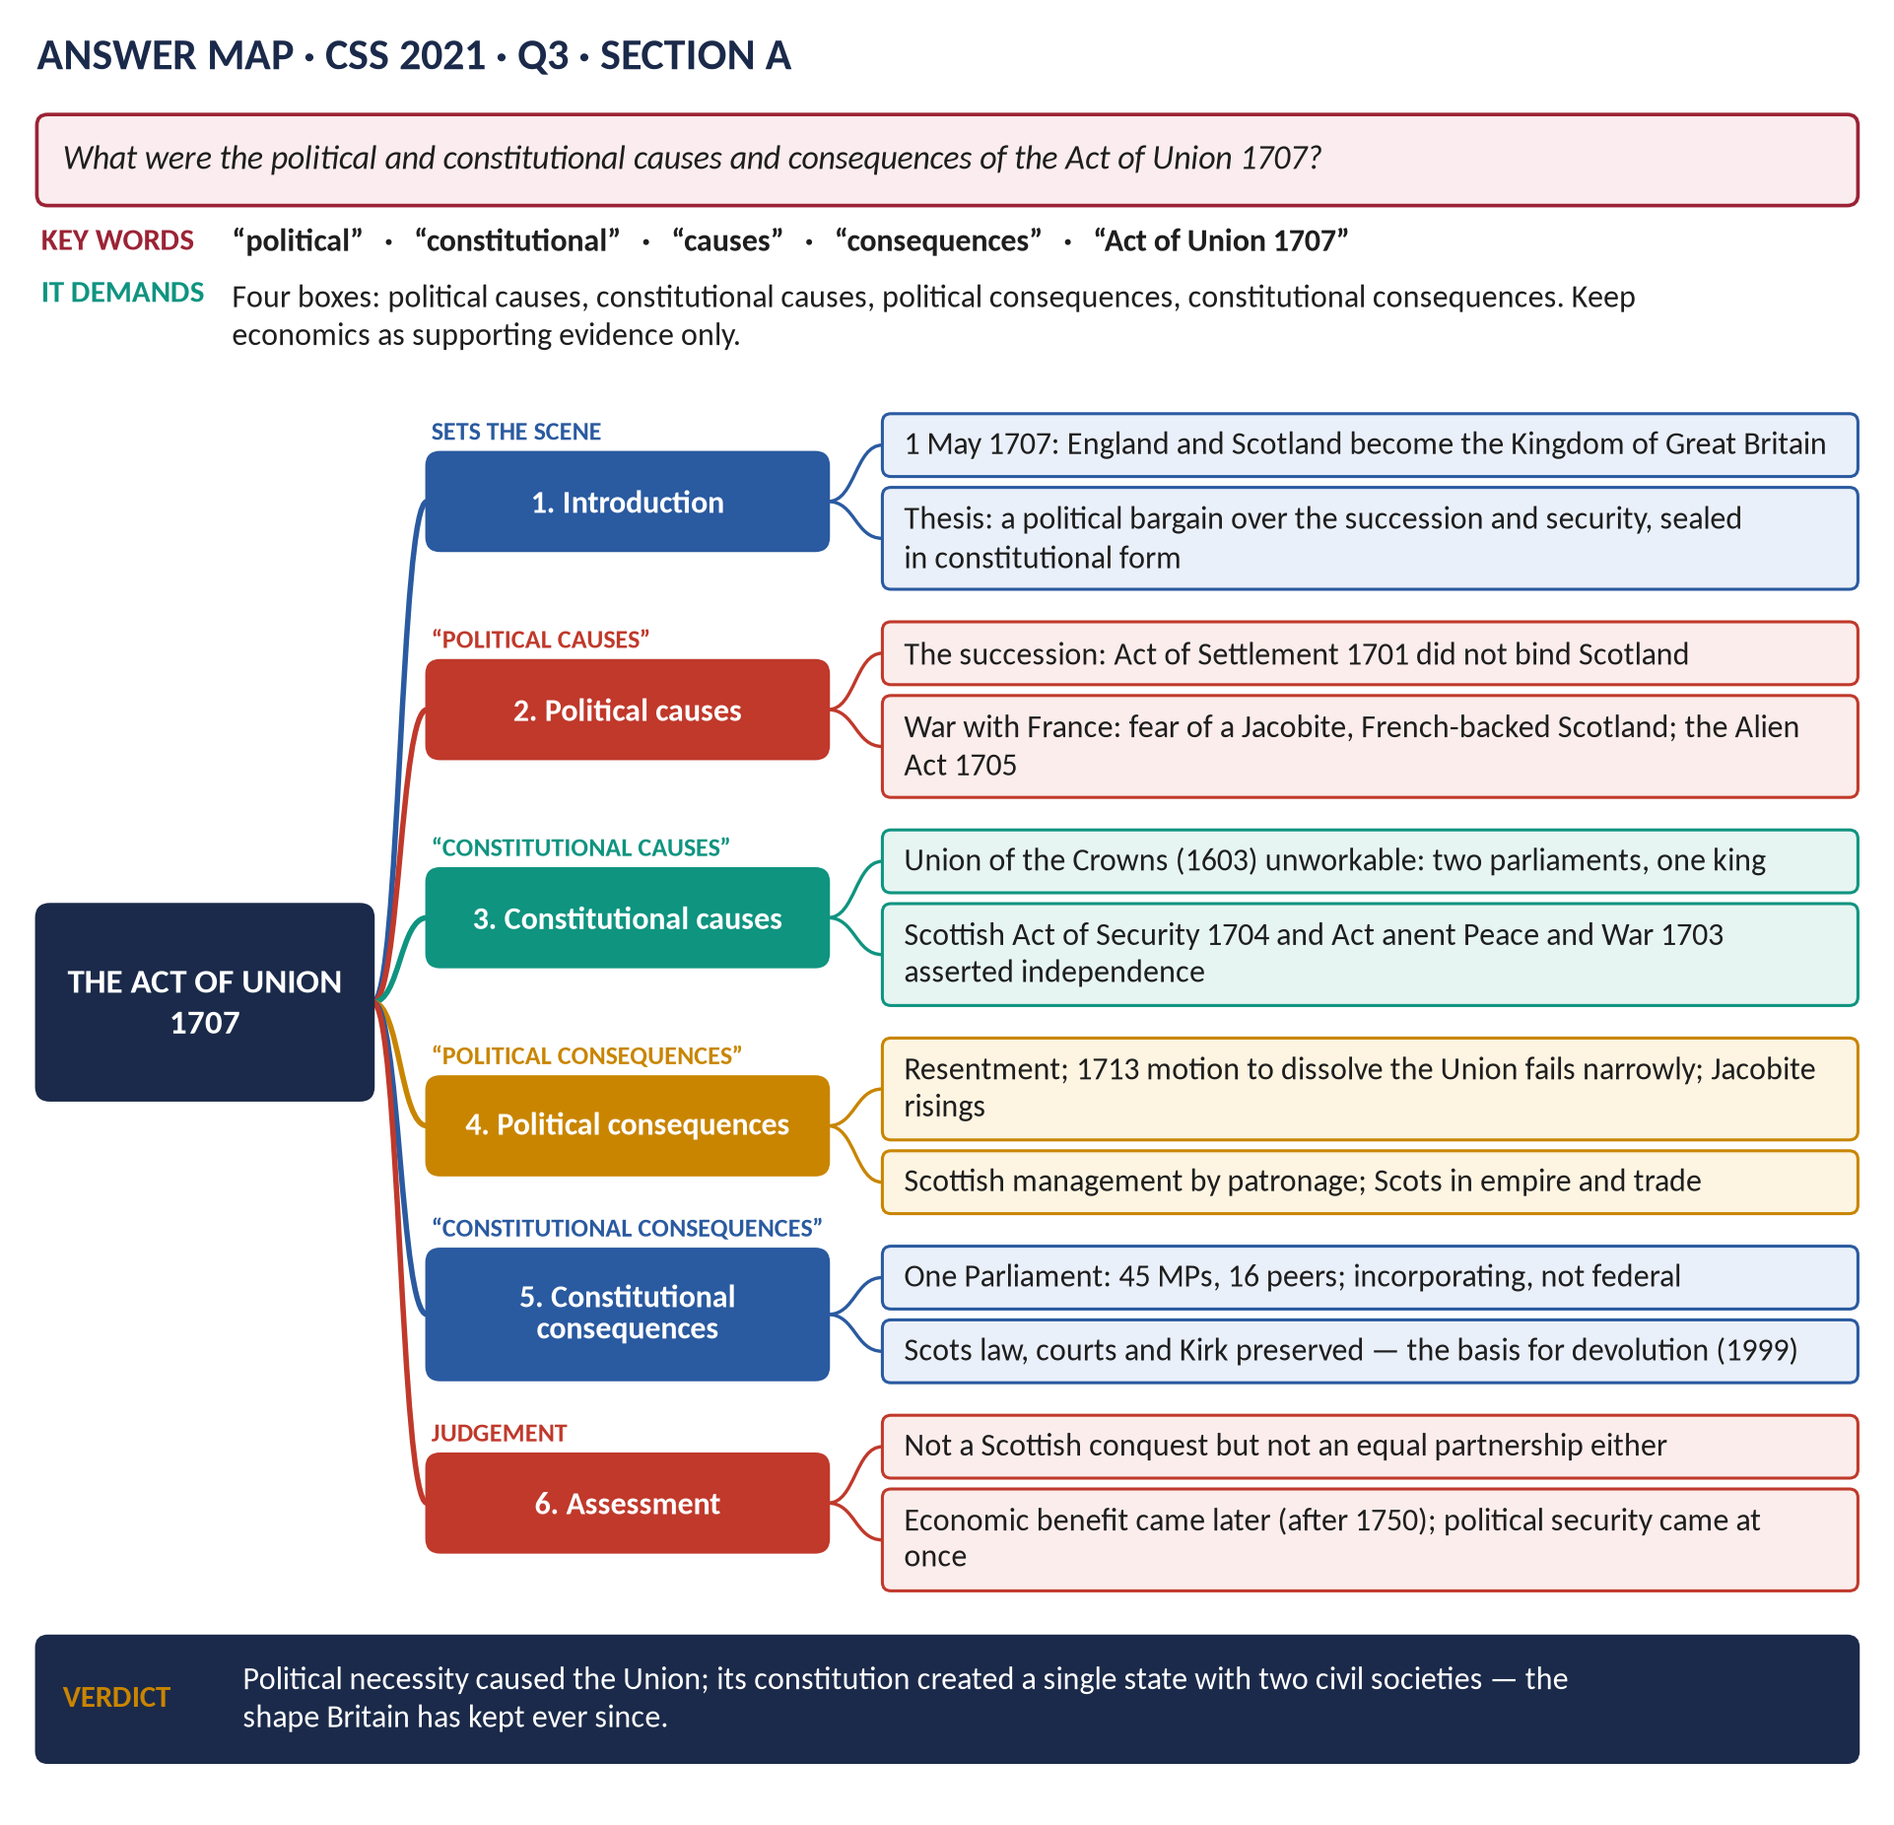
Figure 14 · The answer map for CSS 2021 · Q3 · Section A: every branch is one heading of the answer below.
DECODING THE QUESTION
Four boxes: political causes, constitutional causes, political consequences and constitutional consequences. Economic factors (Darien, trade) are real, but here they are supporting evidence — keep them inside the political argument.

The model answer

(1) Introduction
On 1 May 1707 the kingdoms of England and Scotland, which had shared a monarch since 1603, became one Kingdom of Great Britain with a single Parliament at Westminster. The Union was caused above all by the succession crisis and the war with France, which made a separate Scotland dangerous to England and an isolated Scotland seem unviable to many Scots. Its consequences were an incorporating union that abolished the Scottish Parliament but preserved Scotland's law, courts and Church — a structure that shaped British politics down to devolution in 1999.
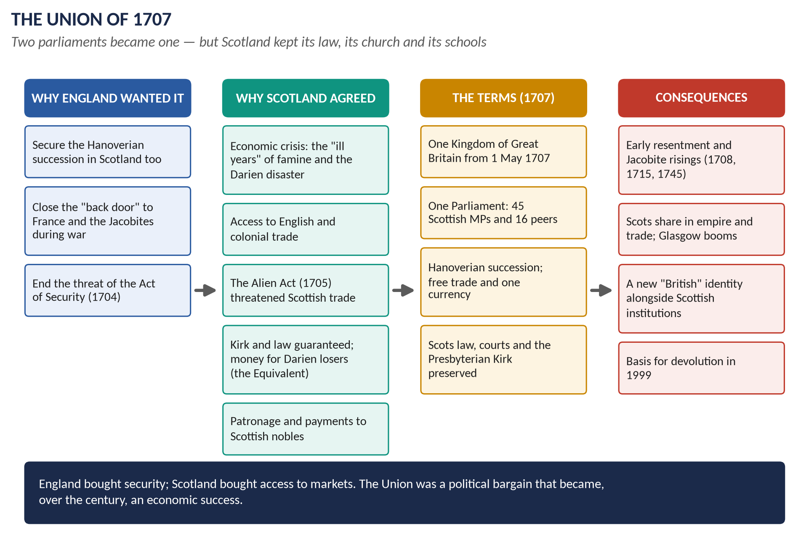
Figure 15 · The Union of 1707 in four columns: England's motives, Scotland's, the terms, and the consequences.

(2) Political causes

(i) The succession
The English Act of Settlement (1701) gave the crown after Anne to Hanover — without consulting Scotland. With Anne childless, a separate Scottish choice could put the Catholic "James III" on the Scottish throne.

(ii) War and security
England was at war with Louis XIV (from 1702). A Jacobite Scotland allied to France would open a "back door" for invasion — as the attempted French landing of 1708 later showed.

(iii) Pressure and management
- The English Alien Act (1705) threatened to treat Scots as foreigners and ban their trade unless they negotiated.
- The Duke of Queensberry and the "Squadrone Volante" delivered votes; about £20,000 was paid to Scottish politicians, and the Equivalent compensated investors — hence Burns's line, "bought and sold for English gold".

(iv) Economic crisis as political pressure
The failure of the Darien colony (1698–1700) cost Scotland perhaps a quarter of its liquid capital; with the famine of the 1690s it convinced many that Scotland needed access to English and colonial markets.

(3) Constitutional causes
1. The regal union of 1603 was unworkable: one king, two parliaments with different interests — especially after 1689, when the Scottish Parliament escaped royal control.
2. Scotland asserted independence: the Act anent Peace and War (1703) claimed the right to decide war and peace; the Act of Security (1704) claimed the right to choose a different successor.
3. Only a union of parliaments could guarantee a single succession and foreign policy.

(4) The terms
- One Kingdom of Great Britain; the Hanoverian succession.
- One Parliament: 45 Scottish MPs (of 558) and 16 representative peers.
- Free trade and navigation; one coinage; taxes equalised with temporary exemptions.
- The Equivalent of £398,085 10s.
- Scots law and courts preserved; a separate Act secured the Presbyterian Church of Scotland.

(5) Political consequences
1. Resentment: the malt tax of 1713 provoked a motion in the Lords to dissolve the Union, defeated by only four votes.
2. Jacobitism drew strength from anti-Union feeling: 1708, 1715, 1745 (Topic 2).
3. Management by patronage: Scotland was governed through great "managers" such as the Dukes of Argyll.
4. In the long run, partnership: Scots entered the Empire, the army and trade; Glasgow's tobacco lords prospered after 1750; a British identity grew alongside a Scottish one (Linda Colley).

(6) Constitutional consequences
1. An incorporating union, not a federal one: the Scottish Parliament ceased to exist.
2. One state, two civil societies: Scotland kept its law, courts, Church and schools, the institutions through which it governed itself day to day.
3. Sovereignty disputed: English lawyers saw the new Parliament as the old English one, with unlimited sovereignty; Scottish lawyers argued the Treaty was a fundamental law that could not be changed.
4. The basis for devolution: the separate institutions preserved in 1707 made the Scottish Parliament of 1999 possible.

(7) Assessment
 | Political | Constitutional
Causes | Succession; war with France; the Alien Act; management | Unworkable regal union; the Acts of 1703–04
Consequences | Resentment and Jacobitism; later partnership in empire | One Parliament; separate law, courts and Kirk; sovereignty debate; devolution

(8) Conclusion
The Union of 1707 was driven by political necessity — the Hanoverian succession and national security in wartime — and made possible by Scotland's economic weakness and skilful management. Its constitution created a single state with two civil societies. At first unpopular and a cause of Jacobite risings, it became over the century an economic and imperial partnership, and its preservation of Scottish institutions shaped the United Kingdom's constitution down to devolution.
WHY THIS ANSWER SCORES
The four named categories each get a heading, and the table at the end proves all four were covered. Economic factors are used as evidence inside the political argument, as the question implies, and the constitutional consequences are traced to 1999.

Part Two — The Past MCQs, Solved
HOW TO USE THIS · The topic's objective questions, 2024–2026
Seven MCQs from the last three papers belong to Topic 1. Each is given with its printed options, the keyed answer and the reason.

CSS 2024 · MCQ 8
The Act of Union between England and Scotland took effect in:
(A) 1717 | (B) 1707 | (C) 1800 | (D) None of these

REMEMBER · Answer: B. 1707
The Treaty of Union was agreed in 1706 and passed by both Parliaments early in 1707; it took effect on 1 May 1707.

CSS 2024 · MCQ 18
The League of Augsburg was signed in:
(A) 20 December 1689 | (B) 20 December 1680 | (C) 20 December 1677 | (D) None of these

REMEMBER · Answer: D. None of these — the League was formed in 1686
The League of Augsburg was formed in July 1686; none of the printed dates is right. (20 December 1689 has no connection with it.)

CSS 2025 · MCQ 1
What key document affirmed parliamentary supremacy after the Glorious Revolution?
(A) Magna Carta | (B) Bill of Rights | (C) Act of Settlement | (D) None of these

REMEMBER · Answer: B. Bill of Rights
The Bill of Rights (1689) declared the suspending power and taxation without Parliament illegal. Magna Carta is from 1215; the Act of Settlement (1701) dealt with the succession.

CSS 2025 · MCQ 2
Which dynasty came to power after the Glorious Revolution?
(A) Stuart | (B) Tudor | (C) Hanoverian | (D) None of these

REMEMBER · Answer: D. None of these — William III of Orange and Mary II (a Stuart) reigned jointly; the Hanoverians began in 1714
William III was of the House of Orange-Nassau; Mary II was a Stuart. No new dynasty came to power — the Hanoverians began only in 1714. So "None of these".

CSS 2025 · MCQ 5
The Act of Union between England and Scotland was passed in:
(A) 1603 | (B) 1707 | (C) 1801 | (D) None of these

REMEMBER · Answer: B. 1707
Negotiated in 1706, the Act of Union was passed in 1707 by both Parliaments. 1603 was the Union of the Crowns; 1801 the Union with Ireland.

CSS 2026 · MCQ 1
Which monarch ruled jointly with William III after 1689?
(A) Henry IV | (B) Anne | (C) Catherine of Braganza | (D) None of these

REMEMBER · Answer: D. None of these — Mary II
Mary II, James II's elder daughter, ruled jointly with William from 1689 until her death in 1694. Anne was her younger sister, who succeeded in 1702.

CSS 2026 · MCQ 2
The Act of Settlement 1701 secured the crown for which house?
(A) Hanover | (B) Bourbon | (C) Habsburg | (D) None of these

REMEMBER · Answer: A. Hanover
The Act of Settlement 1701 gave the crown, after Anne, to Sophia of Hanover and her Protestant heirs; George I succeeded in 1714.

Part Three — Five Predicted Questions, with Outlines
NOTE · Why these five
They come from the topic's blind spots (Master Anatomy, Part 3.6 and the T1 dossier): subjects named in the syllabus, or central to it, that have never been set.

Predicted 1 · "Assess the significance of the Revolution Settlement (1689–1701). Did it create a constitutional monarchy?"
- Thesis: yes in principle — the Crown could no longer govern without Parliament — but not yet in practice; the monarch still chose ministers and made policy.
- Headings: (1) The Settlement defined (Bill of Rights, Mutiny, Toleration, Triennial, Civil List, Act of Settlement) · (2) Powers lost by the Crown · (3) Powers kept (ministers, war, peace, patronage) · (4) The Financial Revolution and annual Parliaments · (5) Limits: no democracy, no Catholic toleration, Ireland · (6) Verdict.
- Figure: the "What the Crown lost" diagram.

Predicted 2 · "Examine the constitutional significance of the Act of Settlement, 1701."
- Thesis: it completed the Revolution Settlement by fixing a Protestant, parliamentary succession and securing the judges.
- Headings: (1) Why it was needed (Gloucester's death 1700; Anne childless) · (2) The succession to Sophia of Hanover · (3) The restrictions on the Crown (Anglican monarch; no foreign wars; judges' tenure; placemen and Privy Council clauses) · (4) Which clauses were repealed and why · (5) Consequences: 1714, the Union of 1707, Jacobitism · (6) Verdict.

Predicted 3 · "Evaluate the reign of William III (1689–1702): his domestic and foreign policies."
- Thesis: a king who used England to fight France, and in doing so strengthened Parliament more than any previous reign.
- Headings: (1) Character and aims · (2) Domestic: the Settlement, the Junto, the Financial Revolution · (3) Scotland and Ireland (Glencoe; the Boyne; Penal Laws) · (4) Foreign: the Nine Years' War and Ryswick · (5) The Partition Treaties and the Spanish question · (6) Verdict.

Predicted 4 · "Why did James II lose his throne within four years? Was his fall the result of his own mistakes?"
- Thesis: mostly — he turned his natural allies against him — but William's European strategy made the fall happen in 1688.
- Headings: (1) A strong start (1685) · (2) Mistakes: army, dispensing power, Church, Declarations, purges · (3) The alienation of the Tories and the Church · (4) 1688: heir, bishops, invitation · (5) The European factor · (6) Collapse of nerve · (7) Verdict.

Predicted 5 · "The Union of 1707 was a victory for English interests rather than a partnership of equals. Discuss."
- Thesis: in 1707 the terms favoured English security, but the guarantees for Scots law and the Kirk, and later prosperity, made it more of a partnership than the critics allow.
- Headings: (1) The case for "English victory": Alien Act, management, 45 MPs against 513 · (2) The case for "partnership": the Kirk, law, the Equivalent, trade · (3) Early reaction: 1713 vote, Jacobitism · (4) Long-term: empire, Enlightenment, British identity · (5) Verdict.

